# Which of the following increases during the change from fetal to neonatal circulation?

* 1. Blood flow through the ductus arteriosus



## Prostacyclin (PGI2) production in the ductus arteriosus

1. Pulmonary artery pressure
2. Right atrial pressure

The Correct Answer is : B. Left atrial pressure

# In the transition from fetal to neonatal circulation, the left atrial pressure increases due to increased

pulmonary blood flow and closure of the foramen ovale.

# In the cardiac cycle, the occurrence of S, is most likely indicated at which of the following labeled points on the ECG or phonocardiogram?

A. A

B. B





E. E

The Correct Answer is : D. D

The occurrence of S. or the S1 heart sound, is most likely indicated at labeled point A on the phonocardiogram. Point D represents the frst heart sound and is caused by the closure of the atrioventricular (AV) valves. This sound is often described as "lub" and is heard at the beginning of systole. or the period of ventricular contraction. On an ECG. the S1 heart sound would not be directly visible, but it can be inferred from the timing of the QRS complex, which represents ventricular depolarization and contraction.

1. A healthy 23-year-old woman engages in strenuous dynamic exercise for 30 minutes. Which of the following is the most likely mechanism of the change in coronary blood flow in this woman during exercise?

## Autonomic-mediated vasodilation of coronary vessels

* 1. Increased upstream perfusion pressure



## Myogenic reflex

1. Release of endothelin

The Correct Answer is : C. Metabolic vasodilation of coronary vessels

During exercise. metabolic vasodilation of coronary vessels increases due to the release of metabolic byproducts such as adenosine, potassium, and hydrogen ions.

1. A62-year-old man comes to the emergency department because of chest pain. Cardiac cathotorization shows blockage of the circumflex branch of the left coronary artery. The occlusion of this vessel most likely damaged which of the following areas of the heart*

## Anterior wall of left ventricle

* 1. Inferior wall of left ventricle
  2. lnterventricular septum



E. Right ventricle

The Correct Answer is : D. Lateral wall of left ventricle

The circumflex branch of the left coronary artery supplies blood to the lateral wall of the left ventricle.

1. In the prossuro-volume loop of a normal heart shown, isovolumetric contraction occurs botwoon which of the following labolod points?

The Correct Answer is ! B. W-X

In be pressure-volume loop of a normal heart, isovolumeVic convaclion occurs between point W and X. I so volumetric contraction refers a the period of time when the venficles are contracfing. but there is no change in ventricular volume. This occurs because the AV valves are closed and blood cannot enter or

leave the venViCles. During this phase of the cardiac cycle, pressure within the venVicles rapidly increases. as the ventricles contract and generate force against be closed valves. This increased pressure is represented by the steep rise in pressure from point W a point X on be pressure-volume loop.

1. **Immediately after ascending from sea level to 2100** m (7000 **ft) above** sea **level,** a healthy 27-year-old woman hyperventilates. Which of the **'following best explains the hyperventilation?**

A. Oecreaalng oxygen concentration In anerial bead atime latea tne carotld ana aonic badlos

e. Dacmasing oxygan saturatlon in anerlaz blood atimuzatao the carotid and aortlc

0. Oecraaoing Pa. in arterial blooa sMmuzates cantraz chernoraceptors

E. Oecreaaln g Pco. in artarlaz blooa otlmuzaio carotld c hemomceptoro

The Correct Answer is ! C. Decreaslng Po: In arterial blood stimulates the carotid and aortlc bodies

### Upon ascent to higher altitude. be decrease in partial pressure of oxygen {Po.) in arterial blood stimulates peripheral chemoreceptors in the carotid and aortic bodies, leading to hyperventilation.

1. A 63-year-old man has had progressive edema in his extremities, pulmonary congestion, and hypotension since having a myocardial infarction 2 days ago His breathing pattern over the past 6 hours is shown. Which o'f the 'following is most likely responsible 'for this cyclic breathing pattern?





E.Impaimento{oxygendlWuslonacfoeealveolarmemofanee



The Correct Answer is ! B. Dysfunction of carotid barorece ptors

Cheyne-Stokes respiration is the cyclic breathing pattern described in the guesfion. and it is characterized by periods of deep, rapid breaking {hyperpnea) alternating with periods of apnea. This pattern is commonly observed in patients with heart failure or conditions fat lead a reduced blood Row to the brain In the context of the patent’s recent myocardial infarction and the development of progressive edema, pulmonary congestion. and hypotension. be most likely cause of Cheyne-Stokes respiration in this case is dysfunction of be carotid baroreceptors. These receptors play a crucial role in main@ining blood pressure and regulating respirafion. and their dysfunction could lead a the observed cyclic breathing pattern.

1. A study is conducted to assess the sensitivity o'f a new diagnostic test 'for streptococcal pharyngitis. Results of the new diagnostic test are compared with results 'from bacterial culture, which is considered the gold standard test. One hundred patients with a suspected diagnosis of streptococcal pharyngitis are tested with both methods. Fifty patients are con **firmed by** bacterial culture to have streptococcal pharyngitis. Sixty patients have a positive test result using the new test, o'f these patients, 75'4 are true positives. According to these results, which o'f the 'following represents the sensitivity of the new test compared with the gold standard test?



The Correct Answer is ! E. 90%

#### The sensiuvity of be new est is calculated as the number of true positive result f45) divided by the tool number of true posiuve and false negative result f50) and multiplied by 100. which results in 90\t.

1. A resting subject is passively tilted 'from the supine to the standing position. This maneuver causes an acute increase in which of the 'following?



The Correct Answer is ! C. Heart rate

When a resting subject is passively tilted from supine to standing position. heart rate increases due to the

activation of the baroreceptor reflex in response to decreased venous return.

1. A 60-year-old man has a decreased functional residual capacity (FRC), a ratio of residual volume to total lung capacity of 15°A (N = 20%) and a forced expiratory volume in 1 sec (FEV) that is 8S°/ of his 'forced vital capacity (N> 75°/ ). He is most likely to have

wh ich of the 'following sets of pulmonary 'findings?

Total Lung Capac lty Lun g Compllance



c. Normal

n ormal

E.

The Correct Answer is ! B. Total Lung Capacity . , Lung Compliance normal

This patent has a decreased functional residual capacity (FRC). a ratio of residual volume to otal lung capacity lower than normal. and an FEV1 that iS within the normal range. These findings are consistent with a restrictive lung disease. which is characterized by a decreased total lung capacity {TLCj and normal lung compliance.

1. In screening 'for diabetes mellitus, a serum glucose concentration of 180 rng/dL instead of 120 rng/dL is used as a cut point 'for normal. Which of the following is the most likely effect on sensitivity and specificity?

Sensitlvity

. De crease

e. De crease

c. De crease



E. Increase

##### F. Increase

c. No change

ri. No change

##### i. No change

decrease Increase no change

Increase no change decrease Increase

no change

Speciflcity

The Correct Answer is ! D. Sensitlvity Increase, Speciflclty decrease

### When be cut point for serum glucose concentration is raised from 120 mg’dL to 180 mg’dL in screening for diabetes melTituS. more people with diabetes will be correctly identified as having the condiuon (increased sensitivity}. while more people without diabetes will be incorrectly identified as having the condition fdecreased specificity).

1. During a study of the intelligence of school-age children, 50 children are given tests that measure the intelligence quotient Othor data are collected including gender, weight, height, the number of parents living in the same residence as the children, and whether one or both parents work outside the home Measurement of which of the following variables is a nominal mea9uremont in this study?



1. Number of paints IIvIng Tn the aamo rooTdonco
2. lumbar of parent worklng ouNlda the homo



The Correct Wswer is ! A. Gender

### Gender is a nominal measurement in his sludy. as it is a categorical variable without a natural order or ranking.

1. A 43-year-old rrian comes to the physician because of progressive shortness of breath during the past year. He has a diagnosis of a-antitrypsin deficiency. A CT scan of the chest is shown and depicts emphysema. Which of the following is identified by the arrow as the lobe most affected by this process





D RTgnt mlddTe lobe



The Correct Answer is: C. Rlghl lower lotie

##### Since the arrow in the classy chest CT is located in the {exterior part of the I lung, the mast likely allénted lobe would be:

C. Right lower lobe

The {exterior part of the I lung is {x?ziar8y ocaJpied by the right lower lobe.

1. A 43-year-old rrian participates in a treadmill exercise test during which the 9peed and angle of incline are increased every 3 minutes. At re9t, hi9 pulse is 74/min and his blood pressure is 138/82 mm Hg. Fourteen rriinutes after ho starts exercising on the treadmill, which is at peak exercise, his pulse is 140/rriin and his blood pressure is 146/86 mm Hg Which of the following changes in rriyocardial oxygen consumption and coronary blood flow are most likely at this time?

Myocardlal Oxygen Consumption Coronary Blood Flow



no change

D. No change

E. No change

no change



The Correct Answer is ! A) k\yocardiaI Oxygen Consumption \, Coronary Blood Plow

### During exercise, the heart works harder to pump blood and deliver oxygen to the working muscles. As a result, myocardial oxygen coUSumption increases. To meet the increased oxygen demand. coronary blood flow also increases. ensuring hat the heart receives adequate oxygen supply.

1. A 20-year-old woman is participating in a 9tudy of skeletal rriu9cle blood flow during dynamic exercise A phonocardiogram is used to establish the timing of the cardiac cycle. In the resting skeletal muscle of this patient, the time of peak blood flow is most likely to occur during which of the following periods?



C.DurIng02

##### o. iu<»dI>t+i/ an>r a2

E.Immedlammly befon* S1

The Correct Answer is ! A. Between SI and S2

#### In resting skeletal muscle, the lime of peak blood Row occurs between the first (S1) and second {52) heart sounds. which coriesponds la the systolic phase of the cardiac cy‹de.

1. A 24-year-old woman who is an athlete has the following arterial blood gas values at rest



Pco. Po.

7.40

95 mm Hg

40 mm Hg

She voluntarily hyperventilates be'fore a 100-m race. Which of the following sets of arterial blood values is most likely to occur immediately following hyperventilation?

PH

1. 7.36

e. 7.38

o. 7.40

E. 7.50

Pco\ fmm Hgl

### 35

38

40

### 30

#### 90

98

95

405

Po. fmm Hg)

#### The Correct Answer is ! C. PH 7.38, Pco2(mm Hg)38, Po. (mm Hg) 105

VoluULary hyperventilation would lead to a decrease in CO. levels due to increased venfilation. resulting in respiratory alkalosis {increased pH . The decreased Pco: and increased Po: values are consismnt wit hyperventilafion.

1. The diagram shows the location of three alveoli in the lungs o'f a healthy erect person. Which o'f the following relationships best describes relative volumes of these alveoli at the end of a normal expiration?

The Correct Answer is ! E. III >II>I

### During normal breathing, the volume of be alveoli changes as air is inhaled and exhaled. In a resting site. the alveoli at dillerent parts of be lung (upper. middle, and lower) have slightly dillerent volumes due to be effect of gravity and the structure of be lung.

At the eral of a normal mpiration (exhalation), If\e volumes of If\e aNeoli n different parts of the lung are as

### Uppe lung (apical reg s): The alveoli in the uppe part of the lung are less aPected by gravity and are gene&Iy smalle in volume compared to those in the k›wer parts of the lung. At the end of normal expiralion, the volume of alveoli in the uppe lung wil be relalively smaler.

Hiddle Ing: The aNeoli n the middle part of the lung ae moderately allénted dy gravity, and ther volume is intermediate beMeen the upper and lower lung alveoli. At the end of normal exp?ation, the volume of alveoli in the middle lung will be moderately large thin those in the upper lung, but slill smaller than the

Lcnve lung (basal regions): The alveoli in the lower part of the lung are most aPected by gravity, which causes them to expand more as the weight of the lung tissue above presses down. This results n a greater volume of the alveoli in the lower lung cnmpaed to the upper and middle lung regions. At the end of normal expiralion, the volume of alveoli in the Icr‹ver lung wil be relatively larger.

SS. A 9•year•old boy of normal height and weight requiree nocturnal **mechanical** ventilaaon to maintain normal anerlal blood gae valuas, during the day, he must be **pravemed from falling** aateep **A defect of which of** the following ie the moat likely cauea of thB patient's condltfon7

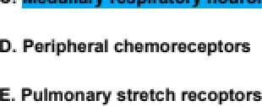

The Correct Answer is : C. Medullary zeaplratory nourona

The patientl condilion, requiring mechnical ventilation at night and prevention from IaIIng ask›ep durng the day, is likely due to a defént in the medullary respratory neurons, which are responsible f‹s the regular of respratory rate and rhythm.

**S6 Wfilch of tke following is the median numbar of urinary tract lnfectione for children In**

### tke eamplo shown In the graph7

C2

. or mv

The Correct Answer is : B. 1

The media in a distrbution is the midclle value when the data is arranged in ascending order. In the case of the given graph, it woidd be the value that separates the lower and up halves of the data.

To detemine the media number of urinary tzad infections, we need to determine which v&ue of episodes falls in the middle of the distribulion of children.

We have:

25 children vrith 0 episc<Ies

30 children vrith 1 episc<Ie

10 children with 2 episodes

35 children vrith 3 or more episodes

This **gives us a total of** 100 children. Tf\e middle **of this distribution would fill between the 50th and 51st child when arranged in order of inaeasing number of episodes.**

##### If we ooat up from the lowest number of episodes, we reanh the 50th child somewhere witfin the group that had 1 episode of urinary mad infection. Theefore, the medl nixnber of urinary tract infedions is 1 episc<Ie.

So the answer is B. 1 episode.

1. Which o'f the following best explains the role of the goblet cell in normal respiration?



D RrovidIng zubrication to protect tna epithelium from



The Correct Answer is ! E. Trapplng particulate materlal on the surface of the respiratory tract

#### Coblet cells produce mucus thai lines the respiratory tract. trapping particulate matter and preventing it from reaching the alveoli.

1. A 62-year-old man with unstable angina pectoris undergoes coronary catheterization followed by angioplasty. During the procedure, the patient is found to have left-dominant coronary circulation. Following angioplasty of the circurnflex artery in this patient, which of the following arteries supplied by the circum'flex artery would receive increased blood flow?



8. Wterior interventrlcu lar daft anterior da#cend Ing|

C. Letoorooaq

The Correct Answer is ! D. Posterior Interventrlcular fposterlor descendlng)

### In left-dominant coronary circulation. the circumflex artery gives rise to the posterior intervenViCular fposterior descending artery.

1. Synthesis and excretion of bile acids are mechanisms the body uses to remove which o'f the following?

0. fatyatda

C. deme



The Correct Answer is ! A. Cholesterol

#### Bile acids are synthesised from cholesterol in be liver and are excreted in bile. which helps a eliminam excess cholesterol from be body.

1. A 1S-year-old boy is brought to the physician for an examination prior to participating on his high school basketball team. He does not smoke cigarettes. He is 185 cm (6 ft 1 in) tall and weighs 78 kg (172 lb). BMI is 23 kg/rn2 His respirations are 14/min. Physical examination shows no abnormalities. He agrees to participate in lung 'function testing as part o'f a study of high school athletes. Pulmonary function tests show

volume

FVC 4.40 L

Functional residual capaclty

Restin g tidal volume 0.70 L

reserve

#### 3.10 L

1.90 L

Which of the following is the most likely estimated residual volume (in L) in th is patient?

E. z ao

The Correct Answer is ! B. 120

Residual volume {RV can be esfimated by Subtracting the sum of expiraory reserve volume {1.90 L) and

resting fidal volume {0.70 L) from be functional residual capacity f3.10 L). 3.10 - f1.90 * 0.70d = 1.20 L.

1. A 'full-term newborn has respiratory distress. Ultrasonography shows that the abdominal organs have eventrated into the left pleural cavity. Abnormal development of wh ich of the 'following embryonic structures is the most likely cause of this newborn's condition?

A.E pnag Imea erm



.Tracneoeaopnag leeptum

The Correct Answer is ! C. Pleuroperitonea I membrane

A congenital diaphragmatic hernia. which allows abdominal organs a enter the pleural cavity. results from the failure of be pleuroperitoneal membrane to close during embryonic development.

1. A 25-year-old man with seizure disorder is brought to the emergency department by his wffe because of progressive shortness o'f breath and coughing since having a generalized tonic-clonic seizure while sitting at the dinner table 24 hours ago. He tells the physician that the gold crown on his left first molar is now missing. If this patient aspirated the crown while sitting, a chest x-ray is most likely to show the crown to be in wh ich of the 'following locations?





The Correct Answer is ! B. Lower lobe of the right lung

### Aspirated foreign Objects are more likely to enmr the right bronchial see due0 its more vertical orientauon. In a sitting posiuon. the lower lobe of the right lung is be most likely location for an aspirated object.

1. Which of the following measures of pulmonary 'function best discriminates between an obstructive and a restrictive disorder?



capactyfVo}E M

The Correct Answer is ! E. Ratlo of FEV1 to FVC

The rafio of forced expiratory volume in 1 second (FEV1j to forced vial capacity (FVC) is used to differentiate between obstructive and restricñve lung disorders. A decreased ratio indicates an obswctive disorder, while a normal or increased ratio suggest a restrictive disorder.

1. A78-year-old man is brought to the emergency department because of a 2-day history of shortness of breath. His rospirations are 30/min. Cracklos are heard over the right rnidc lavicular line at the level of the fifth intercostal space. This location most likely corresponds to which o'f the following?



B. i-ingula

C. han bzonchue

0. M

The Correct Answer is ! E. Upper lobe

Crackles at the right midclavicular line at the level of the fifth inmrcostal space suggest fluid accumuTafion in the upper lobe of the right lung.

1. A26-year-old woman with a 2-week history of excessivo rnonstrual bloeding has a hernoglobin concentration of 10 g/dL. C ornpared with values before her menstrual period, arterial blood values at this time are most likely to be which of the

#### Po.

e.



##### o. Unchanged

Oz Saturation

##### unchanged

unchanged unchanged

Oz Content

 

The Correct Answer is ! E. P o. Un chang ed, O. Saturation unc han ged, D. Content .

### In his case. the woman has experienced excessive menstrual bleeding. which has led to a decrease in her hemoglobin concentration. Hemoglobin is the primary carrier of oxygen in the blood. and a reduction in its concentration will result in a decrease in the overall oxygen content of the blood. However. the partial pressure of oxygen fPo.) and the oxygen saturation of hemoglobin should remain unchanged. as they are not directly affected by the decrease in hemoglobin concentrauon.

1. The graph shows the pressure-volume relationship of the lung (solid curve) and the chest wall (dashed curve). Which of the following letters indicates functional residual capacity?

The Correct Answer is ! B. B

The functional residual capacity (FRC) is indicated by labeled point B on the pressure-volume graph. The FRC is the amount of air that remains in be lungs at\er a normal exhalation and is a measure of the lung's ability to store air. On the pressure-volume graph, the FRC is the volume at which the pressure in be lung is eQual to the pressure in the chest wall. as indicated by be intersection of the solid and dashed curves at point B. The FRC is determined by be elastic properties of the lung and chest wall and the Surface tension of be alveolar fluid, and it is an important factor in determining the lung's ability a exchange gases

1. A healthy 3S-year-old woman is breathing room air while standing. Which of the 'following best explains why alveoli at the top o'f the lungs have a higher Po. than alveoli at the base o'f the lungs in this woman?



0. Lowar perlu aion per unil zung vozume

E. Lowar rate of vanMzaMon io peNuslon

£. Lowar ventilation per unIt sung vozuma

The Correct Answer is ! B. Higher ratio of ventilation to perfusion

### Alveoli at be top of the lungs have a higher Po. than those at the base due a a higher rauo of ventilation to perfusion.

1. A 1-week-old newborn has a continuous "machinery" type murmur caused by a patent ductus arteriosus. The murmur is caused by blood flow from which of the 'following bettered sites in the diagram shown?



e. v to Y

C. W to X

0 . Y to V

E. z to u

The Correct Answer is ! A. U to Z

The machinery type murmur caused by a pawns ductus arteriosus in a newborn is caused by blood flow from labeled sit U0 Z in be diagram. The ductus arteriosus is a normal fetal vessel that connect be pulmonary artery and be aorta and allows blo0d to bypass the fetal lung. In a newborn, the du¢tuS arteriosus usually closes within a few days air birth as the lung begins to funcfion and blood pressure in the aorta increases. However. if the ductus arteriosus remains patent (open , it can result in a continuous murmur as blood flows from the aorta fsite U) to the pulmonary artery tsite Z) instead of being directed to the body. This is known as a paint ductus arteriosus. and it can result in increased blood flow to the lung and decreased blood flow a the body, leading a heart failure and other complications.

1. In which o'f the following tissues does hypoxia elicit vasoconstriction?

C 



E. gKaIetaI muse la

The Correct Answer is ! D. Lung

Hypoxia causes vasoconstriction in the lung to divert blood flow from pOOfly ventilated areas to well-

### ventilamd areas.

1. In erythrocytos, hydrogen ions produced by the dissociation of carbonic acid are bufforod predominantly by which o'f the 'following?





The Correct Answer is ! C. Homoglobln

#### In erythrocyms. hydrogen ions produced by the dissociation of carbonic acid are primarily buffered by hemoglobin.

1. In a healthy adult, blood flow in the loft coronary artery is loss during systole than during diastolo. This difference is best explained by a change in which o'f the following?



The Correct Answer is ! B. Extravascular pressure

Blood flow in be left coronary artery is less during sysole than diastole due to increased extravascular pressure on the coronary vessels during ventricular convaction.

1. A 66-year-old woman is brought to the emergency department because o'f light- headedness for 3 hours. Her pulse is 160/min. An ECG shows a re-entrant atrioventricular tachycardia. After carotid sinus massage is done, her sinus rhythm returns to normal. Which of the following changes in nervous sy stern activity best explains the mechanism o'f action that restored normal sinus rhythm in this patient?

Sympathetl c EWeren t Parasympathetic Efferent

n o c han ge

o. n o c han ge

The Correct Answer is ! E. Sympathetic Efterent. Parasympathetic EWerent

Carofid sinus massage simulates the carofid SiUuS baroreceptors, leading to increased parasympathetic fvagal) activity and decreased sympafetic activity. This helps a slow down the heart rate and can restore normal SiUuS rhythm in some cases of achycardia.

1. A 42-year-old man has a hernoglobin concentration of 11 g/dL. Pulmonary function is normal. Which o'f the 'following values is most likely to be decreased in this patient?
   1. Amoun{DO.coneumpdon



E.PO.offiiabaod

The Correct Answer is ! C. O. content of hls blood

### In his case. the patient has a hemoglobin concentration of 11 g’dL. which is lower than be normal range f13.5-17 5 g/dL for menj. Hemoglobin is be protein in red blood cells that binds to and carries oxygen in be blood. When the hemoglobin concentration is lower Can normal. it indicates that the patient has a reduced oxygen-carrying capacity in Weir blood. This reduction in hemoglobin levels leads to a decrease in be O. content of the blood.

#### The other parameters like 0. consumption. amount of 0. dissolved in be blood. O. saturation. and PO. of the blood are not directly affected by the decrease in hemoglobin concentration. They are more related to factors like lung function, oxygen demand, and the efficiency of oxygen delivery to the tissues. Since the pauent has normal pulmonary function. these other paramemrs are likely to be within normal ranges.

1. A 36-year-old man is admitted to the hospital 'for treatment of pneumonia. A catheter is placed into the right subclavian vein to facilitate intravenous delivery of antibiotic. Three hours later, the patient begins to have difficulty breathing. Respirations are 30/min and shallow. The trachea and the larynx are displaced to the left. An x-ray of the chest shows air in the pleural cavity. Which o'f the 'following is the most likely location o'f the parietal pleural injury during insertion o'f the subclavian venous catheter?



0. Madlaotlnan pzeura

The Correct Answer is ! A. Cervical pleura

The most likely location of parieal pleural injury during insertion of a subclavian venous catheter is be cervical pleura. as it is in close proximity to be subclavian vein.

1. The maintenance of pressure in the arterial tree in diastole is primarily related to which o'f the following histologic characteristics of the arterial system?
   1. 8undleo of longltudinaz rna acne In la aona

8. Cozzagen IIbers In tna aaventiMa of

0. znternaz ezaatic lamIna of artarlaz intima

E. TnIn w nica advantitla in as rlow a

The Correct Answer is ! C. Elastic lamellae In the media of the aorta

#### The mainmnance of pressure in the arterial tree during diastole is primarily related to the elastic IameIIae in the media of be aorta. These elastic fibers store energy during systole and release il during diastole, main@ining arterial pressure.

1. A 6S-year-old woman comes to the physician because of fatigue 'for the past 3 months. Pulse is 80/min. Hematocrit is 32°/ . Echocardiography shows an end-systolic volume of 6S mL and an end -diastolic volume o'f 115 mL. Which o'f the following is the ejection fraction in this patient?
   1. 0.32

The Correct Answer is ! B. 0.43

The ejection fracfion {EF) is a measure of the proportion of blood that is pumped out of the heart with each beat. It is calculated as the stroke volume {SV) divided by the end-diastolic volume fEDVj. In this patient:

#### End-diastolic volume fEDVj = 115 mL End-sysOIic volume fESV) = 65 mL

Stroke volume (SVj = End-diastolic volume - End-systolic volume = 115 mL - 65 mL = 50 mL Ejection fraction (EFj = Stroke volume ’ End-diastolic volume = 50 mL ’ 115 mL = 0.43 or 43\â So the answer is B. 0.43.

1. At the end of a normal expiration, pleural and alveolar pressures are -S and 0 cm H.O, respectively. Which of the following pressures is most likely to be present at the end of max irnum inspiration with the glottis open?

Pleural pressure fcm H.D) Alveolar pressure(cm H.OI

A. -10 •3

#### •3

o. *5 •3

K 5

The Correct Answer is ! B. Pleural pressure fcm H.OI -10, Alveo lar pressurefcm H.OI 0

During maximum inspirafion. the pleural pressure becomes more negafive due a the expansion of the thoracic cavity and the increased negafive pressure within the pleural space. This helps draw more air inc the alveoli. In contrast. alveolar pressure remains at 0 cm H:0 at the end of maximum inspirafion with be gloltis open because the pressure inside the alveoli is eQual to be atmospheric pressure.

1. During strenuous exercise, which o'f the 'following changes most influences total peripheral resistance?
   1. Oecreasad blooo ml acoaity
2. Decreased sympathetic cnolinerglc activity



The Correct Answer is ! D. Vasodilation in skeletal muscIe

During strenuous exercise, vasodilalion in skeletal muscle has be most significant impact on eta peripheral resisance. This vasodilation is due to the local release of vasodilatory subsances, such as adenosine, niVic oxide. and increased issue temperature. which allows increased blood flow to meet the increased metabolic demands of the working muscles.

1. The aortic valve opens at which o'f the 'following bettered points on the ventricular volume curve?

The Correct Answer is ! D. D

The aorfic valve opens at labeled point D on the ventricular volume curve. During the cardiac cycle, the aortic valve opens at the end of venVicular SyStole, when the pressure in be ventricle exceeds be pressure in the aora. This allows blood to be ejected from the ventricle into the aora and ten to the rest of be body. The aorfic valve opening is indicated by be rapid increase in ventricular volume at labeled point D. as blad begins to fill the ventricle during diastole. The aortic valve closing is indicamd by the rapid decrease in ventricular volume at labeled point F. as the ventricle begins O contract again during systole.

1. A 32-year-old man has multiple 'facial fractures after striking the windshield in an automobile collision. He is unconscious. Attempts at oral intubation are unsuccess'ful The most rapid and safe access to the airway is through which o'f the 'following structures?



D. Tnyroepiglotflc ligament



The Correct Answer is ! A. Cricothyroid ligament

In a situation where oral intubation is unsuccessful. and the patient requires an emergency aiMay, a cricothyroomy can be performed. This procedure involves making an incision through be skin and the cricothyroid ligament to establish an airway below be level of the larynx.

### Which of the following points on this flow-volume loop represents peak expiratory flow in a 24-year-old man?

E.E

The Correct Answer is : B. B

A Ilcnv-volixne loop is a graphics representation of the relalionsh@ between airflow' and lung volume during a breathing maneuver, such as a forced mpiration. The kx›p is aeated by plotting the Ilcnv rate of ar being exhaled (in liters pe secnnd) m the x-axis and the lung volume (n liters) m the y-axis.

Peak expiratory flcnv (PEF) is the maximum IJow rate achieved during a f‹xced expiralion and is a commorJy used measicernent of lung kinclion. In the Row'-volume k›op, the PEF is represented by the point of maximum slope on the exhaled Row' traoe, which is Point”B”. This point re{xesents the highest flow rate achieved during the foroed exp?ation, and is a good indicator of the overall health of the respiratory system.

1. Which of the following is the product of the rate-limiting step in the synthesis of cholesterol in a healthy individual?



G COA &



The Correct Answer is ! D. Mevalonate

The raw-limiting step in cholesterol synthesis is the conversion of 3-hydroxy-3-methylglutaryI coenzyme A fHMG-CoA to mevalonate. This reacfion is caraTymd by the enzyme HMC-CoA reductase. which is the primary arget for cholesmrol-lowering drugs known as statins.

1. The tracing shows electrical activity of a sinoatrial node cell. Which of the 'following portions is altered most by the activity of both the sympathetic and parasyrnpathetic nervous sy sterns?

The Correct Answer is ! A. A

The pardon of the electrical activity Of a sinoatrial node cell fat is altered mOSt by the activity of both the sympathefic and parasympathetic nervous systems is the rate of spontaneous depolarization, also known as the automaticity Or "funny" current (lfj. The sympathetic nervous System increases the heart rate by increasing the automaticity Of the sinoatrial node. while the parasympathetic nervous system decreases the heart raw by decreasing the auomati¢ily Of the sinoafial node.

1. Which of the following sets o'f findings is most likely in a 60-year-old woman with chronic obstructive pulmonary disease?

Lung C ompllance Functional ResiduaI Capac ity Forced Vital Capa c ity



The Correct Answer is ! E) Lung Compliance , functional Residual Capacity , Porced Vital Capacity .

In a 60-year-old woman with chronic obswctive pulmonary disease fCOPD). lung compliance iS typically increased due to the loss of elastic recoil. Functional residual capacity fFRCj is increased as a result of air wrapping and hyperinflation. Forced vital capacity (FVCj is decreased because of airflow obstruction and reduced expiratory flow rams.

1. On this spirograrn from a 25-year-old patient, the 'functional residual capacity is represented by the sum of which o'f the following?

The Correct Answer is ! A. Y+Z

The functional residual capacity (FRC} is represenmd by the sum of residual volume fRV) and expiratory reserve volume {ERV) and is represenmd by Y+Z on be spirogram. The FRC is be amount of air that remains in the lungs air a normal exhalation and is a measure of the lung's ability to store air.

1. Which of the following is larger. the standard deviation (SD) or standard *error* of the mean (SEM) calculated 'from ten values?
   1. Eitnar tne g0 or tna SEM can be Nrger. aepan aing on tne aata

8. The SD and SE V are aquad because tney are two terms for tna same





The Correct Answer is ! C. The SD Is always larger

The standard deviation (SD) is a measure of be variability or dispersion within a set of data points, while the sandard error of be mean {SEM) is a measure of the precision of the sample mean as an estimate of the population mean. The SEM is calculated by dividing the SD by the sQuare root of the sample size (nj. Since the sample si2e is always greamr than or equal to 1, the SEM will always be smaller than or equal a the SD.

1. The left ventricu lar pressure -volume loop shown in the graph is obtained 'from a healthy subject. lsovolumetric relaxation occurs between which o'f the following points?



The Correct Answer is ! E. Z-U

The isovolumefic relaxation phase occurs between points Z and U on the left ventricular pressure-volume loop. During this phase. be pressure in the left ventricle decreases rapidly. bud there is no change in volume as the aortic value is still closed. The rapid decrease in pressure allows the left ventricle a fill with blood from the left atrium, preparing it for the next sysolic phase.

##### An enzyme **imrriunoas9ay** for the detection of Chlamydia trachomatis in cervical specimens has a sensitivity of 7S°A and a specificity of 989 when **compared** with **culture.** This test will be used by an HMO to screen women of reproductive age who are receiving their annual examination. A previous study, which used culture to screen 1000 women, determined that the prevalence of infection was 2Y . **In this population, which** of the following i9 the predictive value of a positive screening test?



D.2%

The Correct Answer is ! C. 40%

#### In his popuTalion. lie predictive value of a positive screening test can be caTcuTaled using the formula! PPV

= (sensitivity - prevalence) / |(sensitivity - prevalence) • ((1 - specificity) - (1 - prevaIence))j. Plugging in the given values. PPV = (0.75 0.02) / |(0.75 0.02)* {0 02 - {1 - 0 98))] = 0 015 / 0.015* 0.02 0.02 = 0 015

/ 0.015* 0.0004 = 0 015 / 0 01S4 = 0 40 or 40°A.

1. A newborn who has severe **respiratory** distress cannot be adequately ventilated and dies. **Autopsy** shows a large left-sided diaphragmatic **hernia** containing rriuch of the 9mall and large intestines, the leR lobe of the liver, and the stomach. Which of the following i9 the most likely cause of death?



1. ConeDlcdon D ihegiem veaaeis



E. glen TaryngeaT stenoaIn





The Correct Answer is ! E Severe pulmonary hypoplasia

### The large left-sided diaphragmatic hernia resuT@d in the displacement of abdominal organs into the chest cavity. compressing the lungs and leading la severe pulmonary hypoplasia. This underdevelopment of lie lungs would cause the newborn to have severe respiratory distress and eventually result in death.

1. A 75-year-old man is brought to the emergency department unconscious 30 minutes after being found in his garage by his daughter. He has been despondent since his wife died 4 months ago. His temperature is 37.2•C (99•F), pulse is 120/min, respirations are 20/min, and blood pressure is 140/80 mm Hg. Physical examination shows bright red cheeks. Which o'f the 'following 'findings is most likely?



O. Oecreasad Methamoglobin con oan Wtlon





E. Increased Metñamoglobin concantratlon

The Correct Answer is ! F. Increase d carboxy hemoglob in concentratlon

The patient's bright red cheeks and be fact that he was found in his garage suggest fat he may have been exposed to oarbon monoxide fCOj poisoning. CO binds to hemoglobin, forming carboxyhemoglobin. This reduces the oxygen-mrrying capacity of the blood. leading to issue hypoxia and sympoms Such as headache. dizziness. and eventually unconsciousness.

1. Which of the following phases o'f the ventricular action potential most closely coincides with the T wave of the ECG?

The Correct Answer is ! D. D

1. In the cardiac cycle, the occurrence o'f the diastole is most likely indicated at wh ich of the 'following labeled sites on the ECG or phonocardiogram shown?

The Correct Answer is ! B. B

#### The occurrence of diastole is most likely iUdicamd at labeled sill B on the ECG or phonocardiogram. During diasole. the heart is relaxed and filling with blood. On the ECG. his period of relaxation is represented by the interval between be ORS complex and the T wave, and it is characterized by low volage and a smooth. downward slope. On the phonocardiogram. diastole is characterized by the presence of a "dub" sound. which is produced by the blood flow into the relaxed ventricles.

1. Under normal conditions, the dominant form in which CO2 is carried in arterial blood is which of the following?
   1. Carbam Inonamoglobin

vmCOA

DBCOJ

The Correct Answer is ! C. HCO\

### Under normal conditions. the dominant form in which CO. is carried in arterial blood is as bicarbonate ions fHCO ). CO. is convened to HCO by be enzyme carbonic anhydrase. which caraTymS be reaction of CO. with wamr to form carbonic acid {H.CO which then dissociams into HCO and H .

1. A pharmaceutical company is attempting to develop a new cardiac inotrope by screening plant extracts 'from the Amazon basin. Compounds that bind to and activate wh ich of the 'following receptors will most likely increase cardiac contractility?
   1. a- Ad n0n engic

E. Nicotinic

The Correct Answer is ! B. B-Adrenerglc

Compounds that bind to and activam fi-adrenergic receptors will most likely increase cardiac contractility. Activafion of these recepors increases the levels of invacellular cyclic AMP {cAMP j. which in tub acfivates protein kinase A (PKAj. PM phosphorylates various proteins. leading to an increase in intracellular calcium levels and enhanced contractility.

9S. A 5S-year-old woman is brought to the emergency department because o'f chest pain and shortness of breath for 3 hours. Her pulse is 12S/rnin, respirations are 28/rnin, and blood pressure is 80/40 mm Hg. Physical examination shows poor perfusion to the extremities. Pulmonary angiography shows complete blockage of blood flow to the left lung. Which o'f the 'following labeled points on the ventilation-perfusion line of the

oxygen-carbon dioxide graph best corresponds to the alveolar blood gas o'f the left lung of this patient?

The Correct Answer is ! A. A

The alveolar blood gas of be left lung of this patent is best represented by labeled point A on the ventilafion-perfusion line of the oxygen-carbon dioxide graph. In this oase. the complete blockage of blood flow to the left lung resuTW in a ventilation-perfusion mismatch. with normal venfilation to be lung but no perfusion. This leads to a decrease in Oxygen upâke and an increase in carbon dioxide remntion, resulting in a shift of the alveolar gas towards point A, which represents low oxygen and high carbon dioxide levels. The par perfusion to the extremiñes and the low blood pressure in the patient are consistent wit this pattern of hypoxia and hyperoapnia.

96. A previously healthy SO-year-old man comes to the physician because o'f a

2-week history of progressive shortness of breath with exertion. A tentative diagnosis of pulmonary edema is made. His ability to maintain fluid balance in the pulmonary circulation is determined. The following parameters are measu red:

Filtration coefficient of the endothelial membrane (K) Capillary hydrostatic pressure (Pap

Interstitial hydrostatic pressure (P

Capillary colloid osmotic pressure ( Pi cxp ) Interstitial colloid osmotic pressure ( overline pi lrn )

Coefficient of preventing movement of plasma proteins out of the capillary (reflection coefficient, a)

Total volume o'f liquid crossing the rnicrovascular endothelium o'f the lung and entering the pulmonary tissue spaces is then calculated. This parameter is best represented by wh ich of the 'following calculations?



The Correct Answer is ! A. K[(P cap - P Int) + a(n int - w cap)]

This equation is based on Starling’s law of Ruid filtration and represents the otal volume of IiQuid crossing the microvascular endothelium of the lung and entering the pulmonary tissue spaces. The formula takes into account the hydrostatic pressures and the colloid osmotic pressures acting across the capillary walls. as well as the filtration coefficient and be reflecfion coeFcient for plasma proteins.

97 A 48-year-old woman with alcoholism comes to the physician because of a 6-month history o'f fatigue, yellowish skin, and swelling of the ankles. She has had an 8-kg (17.6- lb) weight gain during this period. She appears cachectic. Physical examination shows a jugular venous pressure of 5 cm. There is jaundice and ankle edema. Her serum albumin concentration is 2.S g/dL. Which of the following is the most likely cause of the edema in this patient?

A. Oecreaaad capllzary nyarostatlc praoout in tne anKzea

8. Oecreaaad capllzary permeability

0. zncreaaed caplzzary nyarostaMc preosum in the ance a

E. zncreaaed caplzzary permeability



The Correct Answer is ! C. Decreased plasma collold osmotic pressure

### In his patient. the edema is most likely based by decreased plasma colloid osmotic pressure due to her low serum albumin concenvation. Albumin iS a major contribuor a plasma colloid osmotic pressure, and lower levels can result in fluid leakage from capillaries into the interstitial spaces. leading to edema.

1. Which of the following is the principal 'factor determining the distribution of blood flow to the various vascular beds?



C. 6ematocrif

o. Lenglh0lthe



The Correct Answer is ! E. Dlameter of the arterioles

The principal factor demrmining the disVibution of blood flow to the various vascular beds is be diameter of the armrioles. Arterioles control blood flow to the capillaries by constricñng or dilating in response to local tissue needs. neural input. and hormonal signals.

1. A 53-year-old woman comes to the emergency department because of sharp, pleuritic right chest pain for the past 2 hours. She was treated with mediastinal radiation therapy for Hodgkin disease 20 years ago. Physical examination shows no other abnormalities. A CT scan of the chest is shown. The abnormal air seen in this image is most likely located between which of the following tissue layers?



C 



The Correct Answer is ! D. Visceral and parietal pleura

a patient wit a hisory of mediasfinal radiation therapy present with sharp. pleuritic chest paid, it may indicate the presence of a pneumothorax. In a pneumoforax, air accumulates between be visceral and parietal pleura. causing be lung to collapse.

1. Examination o'f a 'full-term male newborn shows muffled heart sounds on the left and the point of maxirnal impulse on the right. An x-ray of the chest shows a right-sided cardiac silhouette. Which o'f the following is the most likely cause of this finding?



1. Pemlemniprlmiuvepulmonagveln

The Correct Answer is ! A. AbnormaI loopin g of the pr Imitlve heart tube

An abnormal looping of the primitive heart tube during development oan lead to a condition called dextrocardia, where the heart is located on the right side of the chest. This Would explain the right-sided cardiac silhouette and point of maximal impulse observed in be newborn.

1. A 30-year-old woman is participating in a physiology experiment. The following data are obtained:

ratlon

rate (/min)

##### Pulse (/min)

30

100

0.45

Right ventrlcular oxygen content (mL 0:/mL

bloodI

Len ventricular oxyg en con tent (mI. DmI bloo d)

Oxygen consumptlon (mL/minI

P20

Which of the following best represents the cardiac output (in L/min) in this woman ?

The Correct Answer is ! C. 10

To calculate the cardiac output. we can use be Fick principle. Cardiac Output (COj = Oxygen Consumption fVO:) ’ {Armrial 0: content - Venous 0. content). Given the values in the guesfion. CO = 500 mL

1. A 45-year-old man with severe tricuspid valve prolapse undergoes a valve replacement operation. As the surgeon places sutu res to secure the new valve in place, wh ich of the 'following parts of the conduction systern o'f the heart is most likely to sustain damage?
   1. \n£arnod¥\ II bers
   2. Lirnbuo foaaa ovazis

O. Vooera£orbaud

The Correct Answer is ! A. Atrloventrlcular bundle

### During a tricuspid valve replacement. the atrioventricular {AV} bundle is most likely to sustain damage as it

##### is located close to the ficuspid value annulus. The AV bundle. also known as the bundle of His. plays a

cnJeial role in If\e cnndudion systœn of the hea-I, bnsmiltng electrical signab fzcvn If\e atria to If\e

1. The diffusing capacity of the lung 'for oxygen is decreased by an increase in which of the following?

C. 6ematocrif

The Correct Answer is ! A. Alveolar membrane thlckness

The diBuSing capacity of the lung for oxygen is decreased by as increase in the Sickness of be alveolar membrane. A thicJ‹er membrane creams a greater barrier for the diBuSion of gases, reducing the raw at which oxygen can be transferred from the alveoli to the pulmonary capillaries.

1. Binding of thrombin to which o'f the following molecules converts it 'from a procoagulant to an anticoagulant?



E. von Wizzebrand facto r

The Correct Answer is ! D. Thrombomodulln

### Binding of thrombin to thrombomodulin convert il from a procoagulant to an anticoaguTant. Thrombomodulin is an endolelial cell membrane protein fat. when bound to thrombin. alters its Substram specificity. The thrombin-thrombomodulin complex activates protein C. which in turn inhibit coagulation factors Va and Villa, exhibiting an anucoagulant effect.

1. A 'female newborn has hypoxemia. Echocardiography shows communication between the left and right centric les and a common ventricular outflow tract. The most likely cause of this abnormality is 'failure of which of the following ernbry ologic structures to 'form?



8. Septum prlmurn

C. Septum

setuudumX

The Correct Answer is ! D. Truncoconal septa

##### The question describes a congenital heart defect vrith a come ventricular ou0low tract and a commaication between the left and right ventrides. This is indicalive of a failure of the tmncoconal septa to form, which is responsible f‹s separaling the outflow tracts of the ventricles.

1. An investigator is studying the contraction and relaxation of vascular smooth muscle in an experimental animal model. Which of the 'following describes the most likely order of events during this process?

|  |  |  |  |
| --- | --- | --- | --- |
| Myosin Light Chaln | Binding of Calcium to | Myosin Light Chaln | Calclum Entry Into the |
| Phosphorylatlon | Calmodulin | Dephosphorylation | Cell  • |

c. z 1 4

o. z   1

1

G. 4

1

The Correct Answer is ! E. Myosln Light Chain Phosphorylation3, Binding of Calcium to Calmodulln2 Myosln Light Chain Dephosphorylatlon4, Calcium Entry Into the Cell 1

#### The correct order of events for the contracuon and relaxation of vascular smooth muscle is as follows.

1. Calcium Entry Into be Cell. During be contraction of vascular smooth muscle. an increase in intracellular calcium occurs. Calcium ions enter the cell Trough voltage-gated or receptor-operand calcium channels in the plasma membrane. The increase in intracellular calcium eoncentrafion is the primary trigger for contraction.
2. Binding of Calcium fo Calmodulin. When intracellular calcium levels increase, calcium binds to a protein called oalmoduTin. Calmodulin is a calcium-binding messenger protein that plays a crucial role in smooth muscle convaction.
3. Myosin Light Chain Phosphorylation. The calcium-calmodulin complex activams an enzyme called myosin light chain I‹inase (MLCK). MLCK phosphorylates the myosin light chain. a component of be myosin molecule. Phosphorylation of the myosin light chain enables myosin to interact with actin. initiating muscle convaction Trough the sliding filament mechanism.
4. Myosin Light Chain Dephosphorylation: For the relaxation of vascular smooth muscle, myosin light chain phosphaase (MLCP dephosphorylates the myosin light chain. This process leads to a decrease in the interaction between myosin and acfin. allowing the muscle to relax. SimultaneouSTy, album is pumped out of the cell or back into be sarcoplasmic reticulum. leading to a decrease in intracellular calcium levels. which also promotes muscle relaxation.
5. Which of the following is most likely to cause the change from the solid curve to the dashed curve of the pressure - volume loop shown?
   1. acute mass lve myocardial inla rction

. emorrnaglc enock



The Correct Answer is ! E. Strenu ous exerc ise

Strenuous exercise is most likely to fuse be change from be solid curve to the dashed curve of the pressure-volume loop shown. where end-diastolic volume {EDV) increased, pressure increased. and stroke volume (SV) increased. During exercise. the body demands more oxygen and nutrients. leading to an increase in cardiac ou@ut. The heart adapts by increasing the convaclility. heart rate. and stroke volume.

This resuTW in a higher end-diasOIic volume and pressure, leading to the observed change in be pressure-

##### volume loop.

1. Assuming that body weight in a particular population is normally distributed with a mean of 82 kg (180 lb) and a standard deviation of 4.5 kg (10 lb), which of the following intervals most closely approximates 95'4 o'f the population?
   1. 63-100 ¥@ 140-Z20





E. T7 -BO k$ (1 70 -1 BMI \b}

The Correct Answer is ! B. 88-95 kg (150-210 Ib)

To find the interval that represents 95°é of the population. you can use the empirical rule (68-95-99.7 rule) for a normal distribution. This states that approximately 95\â of be popuTafion falls within +2 standard deviations {SD) from the mean. In this case. be mean is 82 kg and the SD is 4.5 kg. So, the interval would be {82 - 24.5j to f82 + 24.5), which is 68-95 kg.

1. A 32-year-old woman comes to the physician because of a 1-week history of 'facial and tooth pain. The pain began after she had a cold for 2 weeks; her cold symptoms have resolved. Physical examination shows in'fraorbital tenderness. This patient most likely has inflammation of wh ich of the 'following minuses?
   1. EN MOid

C. M



The Correct Answer is ! D. Max Illary

The patient has a history of facial and tooth pain following a cold. with infraorbi@l tenderness on physical examinafion. These Symptoms are most consistent with inflammation of be maxillary sinuses.

##### A 45-year-old woman with asthma comes to the physician because of shortness of breath for 3 days. Bilateral wheezes are heard on auscultation of the chest. Which of the following contributes most to the generation of the wheezes on expiration in this patient?





D. increased pieuiaipiemauie

E. Tntawoatal munch contractlon

The Correct Answer is ! A. Bronchiolar smooth muscle contraction

### In an asthmatic patient. wheezing is primarily mused by broncfliolar smooth muscle contraction. which narrows the aivays and increases aiuay resislance. This leads to lie characleristic wheezing sound heard on expiration.

##### A 52-year-old woman comes to the physician because of hoarseness for 2 weeks. On examination, one vocal fold is deviated toward the mid line and does not abduct during deep inspiration. Dysfunction of which of the following laryngeal muscles is the most likely cause of the lack of abduction?

cilooarytenol6



D Thyroa tan old

E. Trans eve arpenold

The Correct Answer is ! C. Posterior cricoarytenold

#### The inability to abduct the vocal fold during deep inspiration suggests dysfunction of lie posterior cricoarytenoid mus‹de. This muscle is responsible for lie abduction of the vocal folds. allowing for a larger opening for air la pass through during inspiration.

1. Autoregulation of blood flow to an organ depends on reactive changes in which of the following?



The Correct Answer is ! E. Vase ular resistance

Autoregulation of blood flow to an organ depends on reactive changes in vascular resistance. This mechanism allows for be maintenance of consent blad Row despite changes in perfusion pressure.

1. Which of the following regions o'f the vessel wall is likely to have the highest density of label in a cross section o'f an artery stained with irnrnunoperoxidase coupled to an actin antibody?

A. Pasal lam1na

. E at lamella

C. TH niea ad in Mtla



The Correct Answer is : E. Tunica me dia

The tuUica media, which is composed mainly Of Srnoof muscle cells and elastic fibers. is the most likely region to have the highest density of label in an artery cross-section shined wit immunoperoxidase coupled to an actin antibody. as actin is a major component of smooth muscle cells.

1. Which of the following best describes the relative quantities of the subu nits of hernoglobin in a healthy full-term newborn at birth?

The Correct Answer is ! B. a>y>p>

At birth, a healthy full-term newborn will have a higher amount of a-globin and y-globin chains in their hemoglobin, as feel hemoglobin (HbFj is the primary form of hemoglobin during fetal development. HbF has the composition of a2y2.

1. In a healthy person who is standing, which of the following best characterizes findings in the apical regions of the lungs if compared with the basal

Ventllatlon/Perfusion Ratio Compliance Alveolar PD.

e. No change

c. No change

E.

no change

no change

##### no change no change

The Correct Answer is ! D. VentilationlPerfusion Ratio Compliance . Alveolar PO.

#### In a healthy person who is sending. the apical regions of the lungs have a higher ventilation’perfusion ratio fV’Qj. lower compliance. and higher alveolar PO. when compared to the basal regions. This is due to the effects of gravity, which Causes greamr blood flow and ventilation in the dependent regions (he basal regions) of the lungs.

1. A 69-year-old woman is brought to the emergency department 1 hour after the sudden onset of crushing, substernal chest pain and nausea. Physical examination shows palior and diaphoresis. An ECG and an evaluation of serum cardiac enzyme activity confirm a diagnosis o'f a my ocardial infarction o'f the anterior wall. She is admitted to the hospital and treated with a sedative, oxygen, and a tissue plasminogen activator. Following thrombolysis and reperfusion, potentially toxic substances including hydrogen peroxide (H.O.) accumulate in the patient's injured heart muscle. Which of the following enzymes is most likely to neutralize this excess H2O2 by reducing it to water?

C. HAOPM oxioaee

The Correct Answer is ! A. Glutathione peroxldase

### Clutathione peroxidase is the enzyme most likely to neutralize excess H2O2 by reducing it to water, as it is responsible for breaking down hydrogen peroxide and protecung cells from oxidative damage.

##### 117 When a blood vessel is injured or covered, the process leading to hemostasis is initiated. The first step in thi9 process is vascular 9pasm. Platelets **contribute to** vasospa9m in srriall vessel beds by which of the following mechanisrris?

A. ENbomtlon of vascular ondowallaT gon factor

8 France of actln and myoaIn In plawlet



D.ReMameof hromboa honln

E. Cynthia Io of p tagzandIns

The Correct Answer is ! C. Productlon of thromboxane A2

### Platelets contribute to vasospasm in small vessel beds through the production of Iflromboxane A2. a potent vasoconstrictor and platelet aggregator. This helps la limit blood Row and minimize blood loss after vascular injury.

118. A 42-year-old woman comes to the emergency department because of a fever and a productive cough. X-ray films of the chest show pneurrionic consolidation of the **pulmonary** segment between **the horizontal (minor) and oblique** (major) **fis9ure9. Which of** the following lobes is the most likely site of consolidation?







The Correct Answer is ! D. Right upper

#### The question describes pneumonic consolidation of the pulmonary segment between the ho

1. The following variables were measured in a 30-year-old woman during exercise: gen consumption "’ ”“”"

##### Hemoglobin concentration

10 g/100 mL

##### Mean arterial to venous oxygen concentration difference

L

L

b

Which of the following is the mean cardiac output (in U/min) needed to sustain oxygen delivery to tissue?

The Correct Answer is ! C. 10

To calculate the mean cardiac output needed to sustain oxygen delivery to tissue. use the Fick principle! cardiac output = oxygen consumpfion ’ {arterial-venous oxygen content difference). In this oase. the oxygen consumption is 500 mk'min, The hemoglobin concentrafion is 10 g/100 mL. and the mean arterial to venous oxygen concentration difference is 5 mL O2 ’100 mL blood. Therefore. cardiac output = 500 mL/min / 5 mL 02 ’100 mL blood = 10 L/min.

1. Which of the following forms the margin of a physiologic communication between the right and left atria be'fore birth?





The Correct Answer is ! D. Septum secundum

#### The septum secundum forms the margin of the foramen ovale, a physiologic ¢ornmuUicauon between the right and left atria before bird. This opening allows blood to bypass be nonfunctional fetal lungs and be direcmd towards the sysmmic circuTauon.

**F. Platelet-platelet binding, or aggregation, requires** the **interaction** of **fibrinogen with** a receptor on activated **platelets. Which** o'f the **following is** the **most likely composition** o'f this receptor?

* Racer XII |Nagaman facort



1. von Wizzebrand lack or

The Correct Answer is ! C. Glycoprotein Ilb/IlIa

Platelet-platelet binding or aggregation requires the interaction of fibrinogen with glycopromin llb/lIla receptors on activamd platelets. This interacfion helps to form a platelet plug at be site of vascular inju/. contributing to hemostasis.

G.In which o'f the **following portions** o'f the **circulation is blood volume** the **greatest?**





The Correct Answer is ! E. Systemic veins

#### The systemic veins hold be largest portion of blood volume in be circulation. This is because key function as a reservoir for blood and play a crucial role in maintaining venous return a the heart.

H. Which of the **'following** events occurs **during** the expiratory phase o'f respiration?



* E| radon D We ribs



E. Wldening of tne cools mayIn

The Correct Answer is ! D. Relaxatlon of the diaphragm

##### During the exp?atory phase of respration, the diaphragm relaxer, causing it to move upward md reduœ the volume ofthe thoracic cavity. This inwease in pressure vrithin the thoraclc œvity Iörœs air out of the

1. In screening 'for glaucorna, an intraocular pressure of 20 mm Hg instead of 2S mm Hg is used as the cut point for normal. Which of the following is the most likely effect on the predictive values?

##### Positlve Predictive Value

* De crease

decrease

Negative Predictlve Value



|  |  |  |
| --- | --- | --- |
| F. | De crease | no change |
| G. | Increase | decrease |
| H. | Increase | Increase |
| 1. | Increase | no change |
| J. | No change | decrease |
| K. | No change | Increase |

L.No change no change

The Correct Answer is ! B.

Positlve Predictlve Value Decrease Negative Predlctive Value Increase

### By lowering the cut-off point for invaocular pressure from 25 mm Hg to 20 mm Hg, more people will be classified as having pomntial glaucoma. This will result in more false posiuves, which will decrease the posiuve predictive value. However. here will be fewer false negatives. leading to an increase in be negative predictive value.

1. Which of the following is the most likely effect of a S0'4 decrease in impulse conduction velocity through the atrioventricular node?

E. Prolonged d nullon of la QRS inta real on an ECG

The Correct Answer is ! C. Increased PR interval on an ECG

A 50\â decrease in impulse conducfion velocity through the atrioventricular {AV) node would lead to a longer time for be electrical impulse to camel from the atria to the venficles. This would result in an increased PR internal on the ECG, which represents the time between atrial depolarizafion and ventricular depolarization.

1. Which of the **'following** increases oxygen **release from** hernoglobin in **muscle tissue?**
   * Ca nmonoxldepoieonlng





fi. Increased p8

The Correct Answer is ! D. Increased Ieve Is of carbon dioxid e

Increased levels of carbon dioxide in muscle tissue lead to a decrease in pH, promoting be release of oxygen from hemoglobin. This is known as the Bohr effect. where a lower pH and higher carbon dioxide concentration favor the release of oxygen from hemoglobin.

1. In the drawing shown, Lwo air-'filled bubbles composed o'f the same material with no surfactant present are separated by a closed stopcock. Initially, the volume of bubble Y is Lwice that of bubble X. Which o'f the following most likely occurs when the stopcoc k is opened?
   * Bubbw X and bubble Y nave aquaz

C. 8ubble X aecreaaao in vozume by half

0. 8ubble Y cozzapoes compzetazy

E. 8ubble Y aecreaaao in vozume by nail

f. Hochange in volume

The Correct Answer is : B. Bubble X collapses completely

#### Since bubble Y has a larger volume and radius initially, it has lower pressure. When the stopcock is opened. air will flow from the higher pressure bubble {bubble X a the lower pressure bubble fbubble Y). This will cause bubble X to collapse completely as the air moves to eQuali2e the pressure between be two bubbles.

1. A 42-year-old man undergoes angioplasty to open an atherosc lerotic blockage at the origin o'f the circurnflex artery. A balloon catheter is introduced in the femoral artery at the femoral triangle. Which of the following is the most likely sequence of structures traversed by the catheter during this procedure?
   * Common iliac anery-puzmon ary trunk -left





G. External illac arta -puImona trunk-last coronary anery i . zntarnal Iziac anery-aona-Web ooronary anery



The Correct Answer is ! C. External lllac artery-aorta-len coronary artery

During angioplasty. a balloon catheter is invoduced into the femoral artery and travels through the external iliac anery. then the aora, and finally to the left coronary artery (in this case. a access the circumRex artery).

1. A 20°/ increase in which of the following would be most effective in achioving tho groatost incroaso in oxygen content of pulmonary capillary blood in a perfectly homogeneous lung inhaling air at sea level?
   * NomogDbIn POLO



The Correct Answer is ! B. Hemoglobin concentration

#### A 20ñâ increase in hemoglobin concentration would lead a the greatest increase in oxygen content of pulmonary capillary blood. Hemoglobin is responsible for binding and transporting oxygen, and an increase in iW concentration would directly increase be oxygen-carrying capacity of the blood.

1. A 23-year-old woman comes to the physician because of a 3-hour history of sharp left chest wall pain when she breathes deeply or coughs. She also has an 8-day history of fever, headache, nasal congestion, and productive cough. Her temperature is 38•C (100.4°F), and respirations are 18/min. Physical examination shows decreased breath sounds over the left posterior hemithorax. A chest x-ray shows left lower lobe pneumonia and a pleural effusion on the left. Sensory 'fibers in which of the 'following nerves most likely transmit the pain sensation from the chest wall when this patient coughs?



M. Long‹horaccnerve



The Correct Answer is ! B. Intercostal nerves

The intercostal nerves transmit sensory information from the chest wall, including pain sensation. In this case, the sharp left chest wall pain when the patent breathes deeply Or coughs is most likely transmitted by the intercostal nerves.

1. Vitamin K is necessary for normal blood coagulation because o'f which of the following?

G. n complexes *ith pzamze :n the first wave of plamlet aggragauon

. n ind ucea tne rezsa ae of von Willbrand factor



 lf inltiafes inc coniacf pnase by actlvatlng factor fil (piasma tnmmboplastin



The Correct Answer is ! E. I t Is a requlre d c ofactor for y-carboxy lation of proteIn

Vi@min K is necessary for normal blad coagulation because it ace as a cofactor for the gamma- carboxylation of specific proteins involved in blood clotting. such as factors II. VII. IX, and X. as well as proteins C. S. and Z.

1. Depolarization (phase 0) o'f cardiac pacemaker cells is slower than that o'f ventricular rnyocytes and depends on which of the following ion movements?

#### s. caz+



O. Na+ in 1'\ul¥



The Correct Answer is ! B. Ca+ influx

Depolarization fphase 0 of cardiac pacemaker cells is slower than that of ventricular myocyms and depends on the influx of caTeium ions fCa2+ through L-type calcium channels. This slower depolari2ation is responsible for the sponaneous generation of action pomntials in pacemaker cells.

1. Cutaneous vasoconstriction is caused by an increase in which of the following?
2. Act:vlty of aympatnet nerase that reinae



D.Commmpera€x



The Correct Answer is ! C. Activ Ity of sympathetic nerves that release norepmephrine

##### CiJtaneous vasooonslriction is caused by inweased activity of sympathetic nerves that release norepnephrine. This neurotransmitter dinds to alpha-adrenergie receptors on vascidar smooth musnle celb, causng vasoconstriction and redueing dlood IJow to the skn.

1. Which of the following will decrease in a healthy person during acute exposure to high altitude (4000 rn [13,000 ft])?





The Correct Answer is ! B. Arterial PCO:

#### During acute exposure to high altitude. arterial PCO. decreases as a result Of hyperventilation in response to lower oxygen levels. This increased ventilation helps increase be oxygen saturation of hemoglobin in the lungs. compensating for be lower atmospheric oxygen concentration.

S4. Which of the following is most likely to stimulate the release o'f aldosterone from the adrenal gland?

J. A dacmasa In tna oamozazlty of tne plasma

K. A dacmasa In tna mzeaaa of renin b'y tne Kénay

L. W Increase in the anerial b+oaa pmssure



The Correct Answer is ! E. An Increase In the rate of conversion of anglotensln I to angiotensin II

The release of aldosterone from the adrenal gland is stimulated by an increase in the rate of conversion of angiotensin I a angiotensin II. Angiotensin II is a potent vasoconstri¢tor and simulates aldosterone secretion, which in turn promotes sodium and water retention, increasing blad volume and blood pressure.

5S. Which of the following is the intracellular second messenger generated following nitric oxide binding to its receptor in vascular smooth muscle cells?

C. Calcium



The Correct Answer is ! D. cGMP

The intracellular second messenger generated following nitric oxide binding to its receptor in vascular smooth muscle cells is cyclic guanosine monophosphate (cCMP). NiVic oxide activates guanylyl cyclase, which converts CTP a cCMP. The increase in cGMP leads to the actuation of protein kinase C, which ultimately oauses relaxafion of the vascular smoof muscle cells and vasodilation.

17.

32 *mm Hg*

25 *mm Hg*

Cap lllary hydrostatlc pressure Capillary oncotic pressure

Interstltial hy drostatic press ure InterstitlaI onc otlc pressure

d mm Hg

li mm Hg

Given tke valuaa ehowri, which of the following ie the magnitude and direction of the net preaaura acrose the capillary7



The Correct Answer is : A. 2 mm Hg, IllbaMozs

To deterniine the net pressure aaœs the capilary, we need to œnsider bath hydrastatin and oncotie pressures. The net fillration pressure is the diPerenœ between the capil\ary hydrastatie pressure (32 mm

I-Ig) and the interstilial hydrostalic pressure (0 mm I-Ig), resulling in a 32 mm I-Ig pressure favoring filtration The net oncotic pressure is the drlferenoe beMeen the cap£lary oroolic pressure (25 mm I-Ig) and the interstiti& oroolic pressure (5 mm I-Ig), resulling in a 20 mm I-Ig pressure favoring . The net pressure across the capill is the diPererice between thèse two values (32 - 20 = 2 mm I-Ig) and is n the drection of filtration.

x. In the illustration o'f the alveolar wall, which o'f the 'following labeled cells produces a substance that lowers alveolar surface tension?

L. B

The Correct Answer is ! D. D

Labeled cell D in the illustrafion of the alveolar wall produms a substance that lowers alveolar surface tension. The alveolar surface mnsion is caused by the atvaction of the water molecules in the alveolar fluid to each other. This surface tension can cause the alveoli to collapse during exhalafion. making if difficult for air to enmr be alveoli during inspiration. Cell D in be illusvation is a type of alveolar epiWelial cell known as a type II pneumocym, which produces a Substance called surfacrant fat reduces the surface tension in the alveoli. Surfacant is a mixture of lipids and proteins that reduces the attraction between the water molecules in the alveolar fluid. making it easier for the alveoli to remain open during both inspiration and expirafion.

L. The diagram shows stroke volume as a function o'f right atrial pressu re. The solid curve shows normal cardiac function. Movement 'from point X on the solid curve to point Y on the dashed curve is most likely to be caused by which o'f the 'following physiologic changes?

R. Decreased he rt raw

S. Inereased a1HrI0ad

T. Inereased vaGeular olume



The Correct Answer is ! E. Stimulatlon of the sympathetic nerves to the hea rt

Sympathefic stimulation increases the convactility of the heart. which leads to an increase in smoke volume. It also increases heart raw, which can contribum to a decrease in right axial pressure as blood is pumped more efficiently from the alia to the ventricles.

##### M. **During** an experiment, type II pneurriocytes are found to produce a phospholipid- protein **mixture** that decreases alveolar surface tension. This decrease is most likely to have which of the following effects?

‹›. Decreased azveozar Poo.

P. Decreased compzlance

1. Oecmased osygen diffusing



E. Tncreasad oxygen dlfkalng capaclty

The Correct Answer is ! D. Increased compIIance

### The phospholipid-protein mixture produced by type II pneumocytes is known as surlactant. Surfac\ant reduces alveolar surface tension. preventing the alveoli from collapsing and thus increasing lung compliance.

##### u. A 25-year-old rrian comes to the physician because of frequent nosebleeds **during** the past 6 weeks. Vital signs are within **norrrial lirriits.** Physical examination shows dried blood in the right naris. Direct nasopharyngoscopy shows that the bleeding originates from a vessel at the posterior a9pect of the right middle concha. Which of the following arteries is the most likely source of this patient's epistaxis?







The Correct Answer is ! D. Sphen opalatine

### The sphenopalatine artery is a branch of the maxillary artery and is the most common source of bleeding in cases of posterior epistaxis.

o. Which o'f the following carries the most highly oxygenated blood in the ernbry o?



R. Rulmonar



The Correct Answer is ! E. Umbilical arteries

The umbilical vein carries the most highly ox ygenated blood in be embryo. as it transports Oxygen and nuVients from the placenta to the fetus. The umbilical arteries return deoxygenated blood from the fetus to the placenta.

1. A 40-year-old man **participating in a** study of h igh altitude for 2 weeks shows an increase in hornatocrit from his usual 40% to 50”/ when at sea level. Which of the 'following organs has the greatest involvement in stimulating this increase?

f. Livef



The Correct Answer is ! B. Kidney

Erythropoietin fEPO) is a hormone primarily produced by the kidneys in response to hypoxia. which

stimulates the production of red blood cells and increases the hematocrit.

1. Which of the following laboled figures best describes the relationship beLwoon alveolar ventilation and arteriai Pco.?
2. c
3. a

#### e

The Correct Answer is ! B. B

Labeled figure B best describes the relationship between alveolar ventilation and arterial Pco2. Alveolar ventilafion refers to the amount of air fat reaches the alveoli in the lung, and arterial Pco2 refers to the partial pressure of carbon dioxide in the armrial blad. The relafionship between alveolar ventilation and arterial Pco2 is described by the alveolar gas equation. which states that alveolar ventilation and arteria Pco2 are inversely proportional. This means that as alveolar ventilation increases. arterial P¢o2 decreases. and vice versa. The graph in labeled figure B represents his inverse relationship. with an increase in alveolar venfilafion {represented by the upward slope of the line leading to a decrease in arterial Pco2 frepresented by the downward slope of the line).

25 A6-year-old boy is brought to the physician by hi9 mother because of intermittent upper abdorriinal pain during the past 5 weeks and a rash for 1 week Vital 9ign9 are normal. Physical examination 9hows yellow nodules over the estensor surfaces of the upper extremities There is hepatomegaly and tenderness on palpation of the epigastric region Serurri studies show an increased amylase activity, increased chylomicron concentration, and a markedly increased triglyceride concentration Three months after beginning a fat- restricted diet, his serurri chylomicron and triglyceride concentrations decrease significantly, and the skin lesions resolve. A deficiency of which of the following enzymes is the most likely cause of these findings?

D.AceiylIoAcarboxyIame

E. HMG6oA Tyaae

£. HMG6oA reductasa

G. Hormone enaltlv



The Correct Answer is ! E. Llpoprote in lipase

The patient*s symptoms. including elevated chylomicron and triglyceride concentrations, indicate a deficiency in lipoprotein lipase. This enzyme is responsible for Ihe hydrolysis of Iriglycerides in chylomicrons and very low-density lipoproteins {VLDL). A fat-restricted diet can help manage Ihe condition by reducing the levels of chylomicrons and triglycerides in the blood.

##### s. An 18-year-old woman with congenital pulmonary stenosis comes to the physician for a routine **evaluation.** Part of her **evaluation** includes a chest x-ray to assess the cardiac silhouette for the presence of poststenotic dilution of the pulmonary trunk. If dilution i9 present in this patient, which of the following labeled **structures** on the norma chest x-ray shown is most likely to be enlarged?

The Correct Answer is ! D. D

If dilation is present in this patient with congenial pulmonary stenosis, the pulmonary trunk {labeled structure Dj is most likely to be enlarged. Pulmonary stenosis is a condition in which the pulmonary value, which separates the right ventricle from the pulmonary trunk. is narrowed. limiting the flow of blood from the right ventricle to the lungs. This oan result in increased pressure in the right venVicle and poststenotic dilation of the pulmonary trunk, as the vessel tries a accommodate the increased blood Row. On a chest x- ray, this dilation is seen as an enlarged pulmonary trunk. which is labeled as swcture D in be normal chest x-ray. This dilafion oan be assessed by comparing be si2e of be pulmonary sunk a the aortic knob. which is labeled as structure C in the x-ray.

x. A 5S-year-old woman with severe pulmonary fibrosis undergoes pulmonary 'function testing. Which o'f the 'following 'findings is most likely in this patient?



C. Oecreasad r¥ of breatnIng



The Correct Answer is ! B. Decreased lung compllance

Pulmonary fibrosis causes scarring and stiffening of lung tissue. which resuTfs in decreased lung

##### compliance.

28. A 40-year-old woman comes to be physician because of a 3-month history of the sensafion that food gets lodged within her chest soon after she swallows. She has a history of rheumatic heart disease in childhood. Physical examination shows no supraclavicular adenopathy A grade 2 ’6. apical diastolic murmur is heard fat is described as a "rumble." A lateral chest x-ray with barium ¢ontrasf is shown Which of be following cardiovascular svuctures indicated by the Up of the arrow is most likely musing this patient's symptoms*

### 61. arm o‹tna aona



1. Left ma n iele

g. Fignt atrium



The Correct Answer is : C. Left atrium

##### The patlent's symptoms of food gettlng lodged wlthln her chest aher swallowlng suggest an esophageal compresslon. In the context of a hlstory of rheumatic heart disease, it is likely that the len atrium is enlarged, whlch can cause compression of the esophagus and lead to the patient's symptoms. Addltionally, the presence of a dlastolic murmur frumble) at the apex suggests possible mltral stenosls, which Is commonly associated with rheumatlc heart dlsease and can cause leh atrial enlargement.

1. The cell labeled X in the electron micrograph shown illustrates a region within the lung that is responsible for which of the following?

U. Linlng an aIWoIuG

V. LinIng a blood sea ael



namoglobin E.

The Correct Answer is ! E. Producing surta ctan t

Based on be electron micrograph, the cell labeled X is most likely responsible for producing surfactant. Surfacânt is a subsance produced by Sp'e¢ialized cells in be lungs called type II alveolar cells. IW function is to redum the surface tension at the air-liquid interface within the alveoli. preventing them from collapsing and maintaining normal lung funcfion. The appearance of the cell in the micrograph. with its UumerouS key lamellar bodies. is consistent wit a type II alveolar cell producing Surfacrant. The cell iS not likely to be involved in lining an alveolus, Mining a blood vessel. producing elastic. or producing hemoglobin.

1. A 2-week-old newborn is brought to the physician because o'f fever and cough for 3 days. Her temperature is 37 8•C (100°F). pulse is 104/min, and respirations are 40/min. Examination shows no abnormalities. An x-ray of the chest is shown Which o'f the 'following is the most accurate interpretation of the density in the right lung field?



O. New n0b\aâ £oMa



The Correct Answer is ! F. NormaI thymus

the density On the chest x-ray appears consistent wit the thymus {a normal svucture in infants). The thymus is often large in infants and may be misinterpremd as a mass or oder pathology. Fever in this case

may be due to a different cause unrelated to the chest x-ray findings.

6S. Which of the following findings at the apex best explains why

ventilation-perfusion ratios are higher at the apex than the base of a normal upright lung?





The Correct Answer is : E. Perfusion is lower

##### Ventllatlon-perfusion ratios are higher at the apex of the lung because perfuslon Is lower there than at the base of the lung. This Is due to gravitational effects on blood flow.

1. Which of the following compounds in erythrocytes is decreased in patients with a deficiency o'f glucose-6-phosphate dehydrogenase?



E. NAOP+

The Correct Answer is : D. NADPH

##### Glucose-6-phosphate dehydrogenase fG6PD) Is involved In the production of NADPH, whlch Is essentla for protectlng erythrocytes against oxldative stress. A deficiency In G8PD results In a decreased level of NADPH in erythrocytes, maklng them more susceptlble to oxidative damage.

1. A transient decrease in intrathoracic pressure increases pulmonary vascular capacitance and decreases pulmonary vascular resistance. When the decrease in intrathoracic pressure occurs during ventricular diastole, closure of the pulrnonic valve is delayed. Wh ich of the 'following heart sounds is most likely to be heard as a result o'f these events?

X. Openngsnap



C. S?

F.M

The Correct Answer is : D. Splitñng of S2

##### A transient decrease in Intrathoraclc pressure during ventricular dlastole delays the closure of the pulmonlc valve, resultlng in the splitting of the second heart sound (52).

1. A 40-year-old man has the following findings on pulmonary 'function testing:

Tidal volume 500 mL Dead space volume 150 mL Residual volume 1000 mI

Respiratory raw is 16/min. Which of be following is his alveolar ventilafion (in k'min)?

C s6

The Correct Answer is : A. 3.2

Alveolar ventilation can be calculated as (Tidal volume - Dead space volumel " Respiratory rate, whlch is f500 mL - J50 mL) • 1I'm In = 3.2 LimIn.

### 35 A 4-year-old girl has large xanlomas on the surfaces of her elbows and Achilles mndons. Her serum total cholesmrol concentration is 840 mg’dl, serum HDL cholesterol concenvation is 70 mg’dl. and serum triglyceride concentration is 110 mg’dL. Cholesterol concentrations do not change with administration of an HMG-Cat reducase inhibitor. The most likely cause is absence of mRNA for which of the following promins?

P. Apozipoprotein 8100





C. Lipoprotein lipasc

F. Lysoaom¢l cholc etc fol catcfaac

#### The Correct Answer is : D. LDL-receptor

##### The patlent's symptoms and lack of response to HMG-CoA reductase Inhibitors suggest famlllal hypercholesterolemla, which Is typlcally caused by a deflclency or absence of functional LDL receptors.

36. In the last 8 weeks of gesâtion, extramedullary hemaopoiesis is most likely to occur in which of the following?

H



U. Lymph note s



#### The Correct Answer is : C. Liver

##### In the last 8 weeks of gestatlon, extramedullary hematopoiesls fblood cell productlon outside the bone marrow) prlmarlly occurs in the liver.

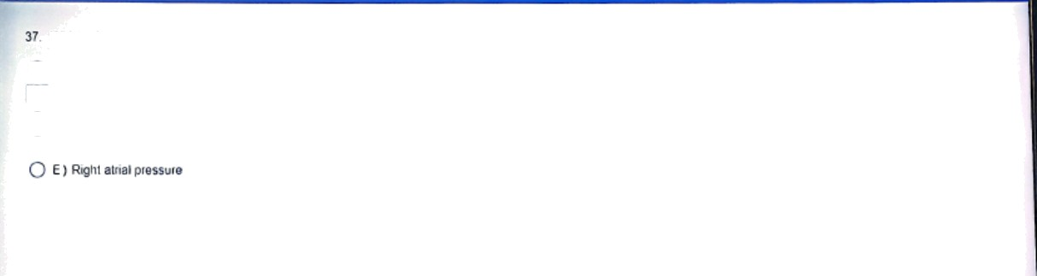

WhKh 0! IN 0!lD\Y!D'g iFt£re85eS Eluting I(TO CI\8i\g6 \fOITt !6lM IO 0 U!8I C fCu!£fh¢Xt†

A) Bto0‹l fbW llvough th8 d ICT\IS orje,osUs

*”6 ”|* B ) LeI1 0ifi8l Die5MFe

O

C› Prosiawc n ‹P6it› pod‹ clean in the ductus anei›ouis

O •› In onary aneiy o‹essuie



38 In the te‹die< cy‹e, lhe Occutre ra 0I S, S use INel at which 0l ttta iolDxing Nbefed Po:nls on Ihe ECG at phonoca•diogtam?

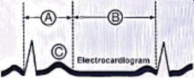

O › •



O s



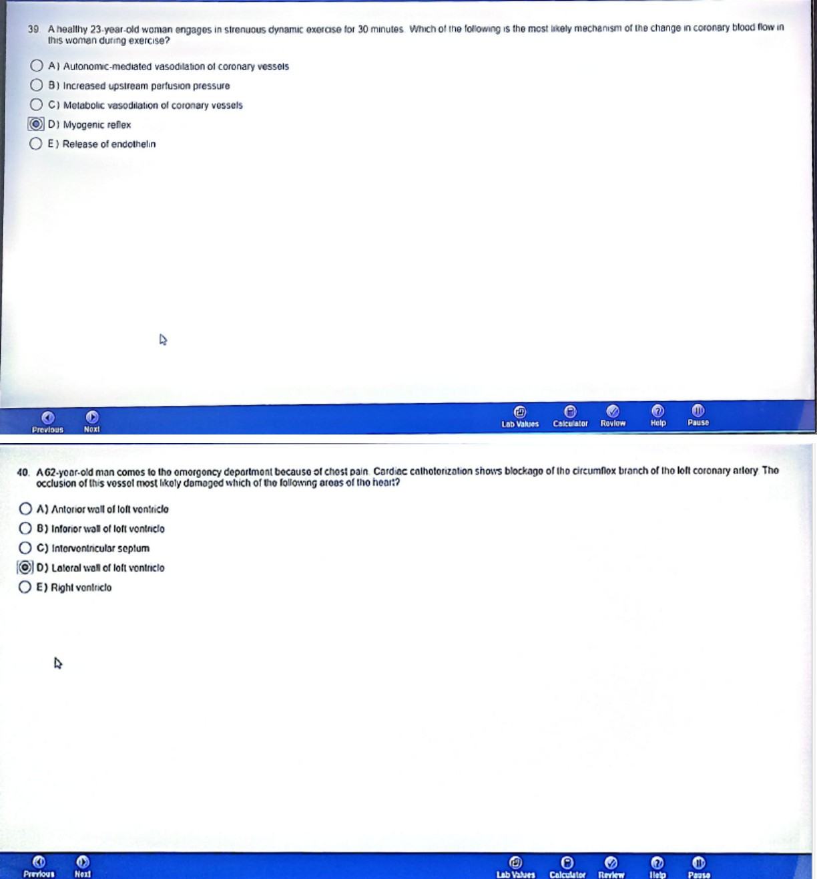

41 ki z 0 pi9s'st›f0-wtU«'i0 are 9t 0 'I‹›t‹n0) ftO0ct sArr 6gxg1\›‹yi0lK COI1tfg¢t›on»¢¢Ufs b0t soon w•Ch 91 lhg fPll0wi‹›g l0b0i0d



O » u•v•w



CI X•Y•Z

# O •›zu

1

‘i



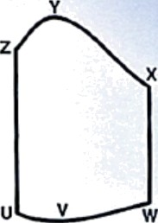

0 iz0

20 -

80-

Loll vontrlcultt \’otvmo mL)



42 lmrn0deIe/y acer ascending mo› sea level To 2100 ni I IO i0 II) at›ove saa level, a hea!\fiy 27 yeaf old can hypervenI›/ales tYIi<h ol Cha following !›esI explains the

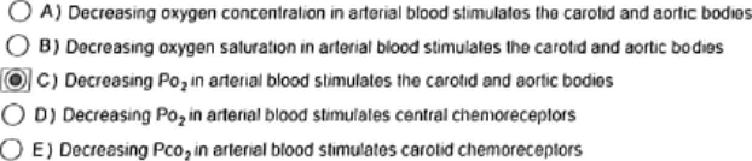



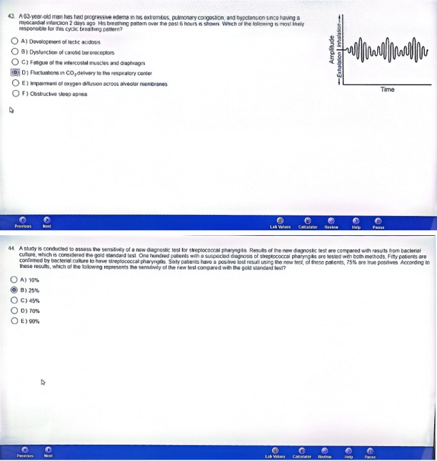

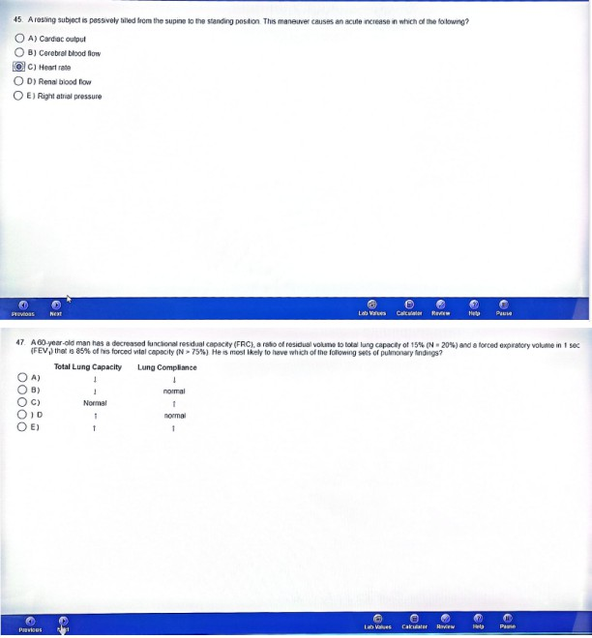

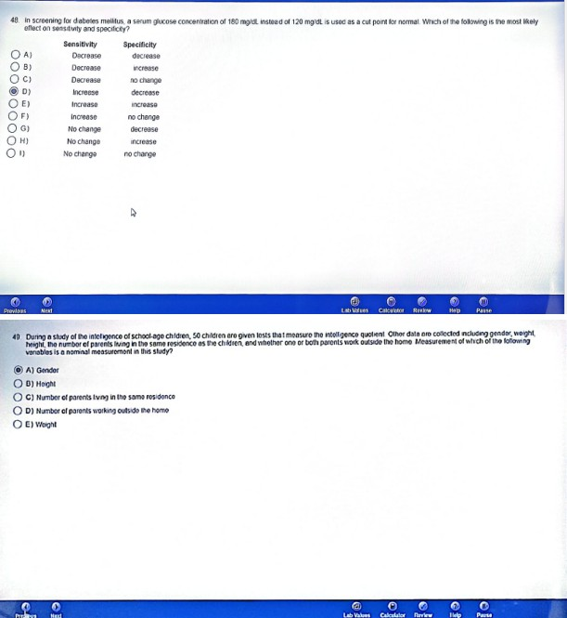

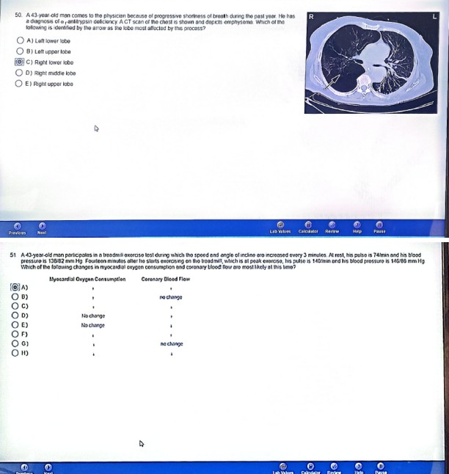

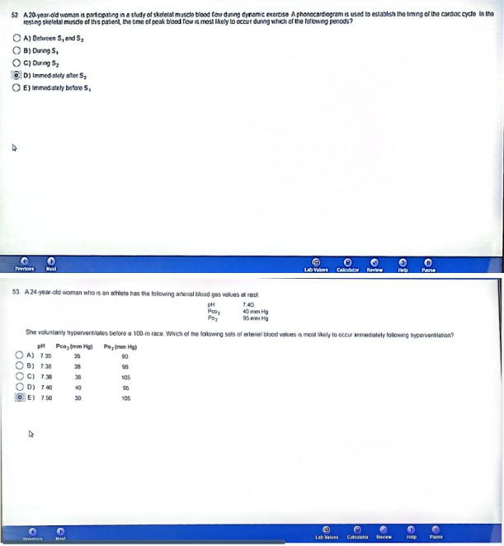

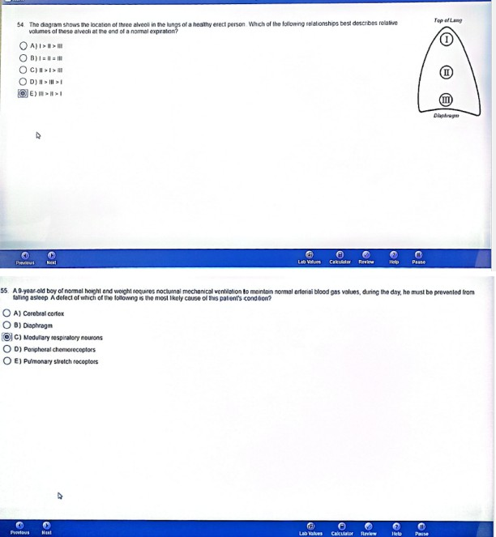

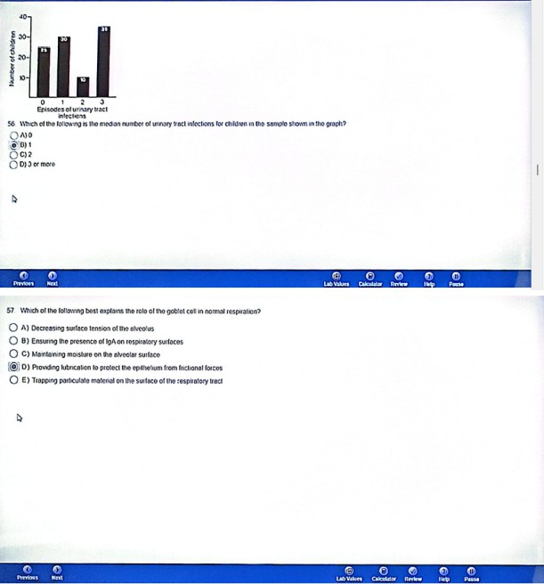

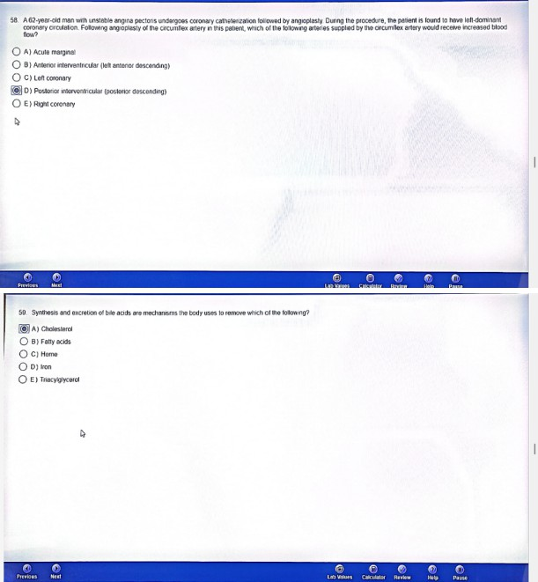

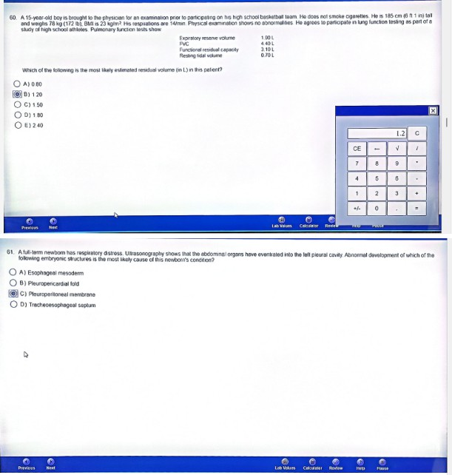

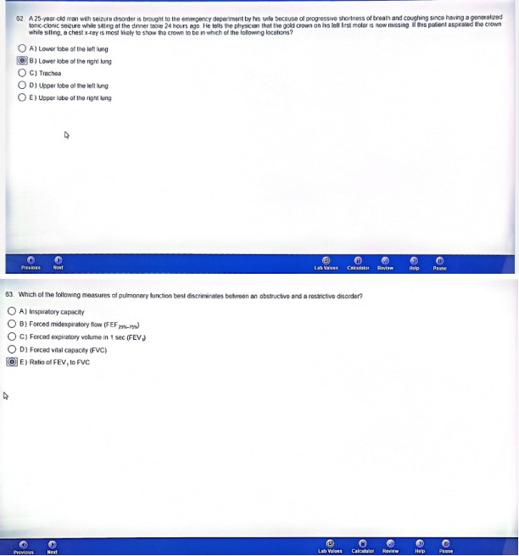

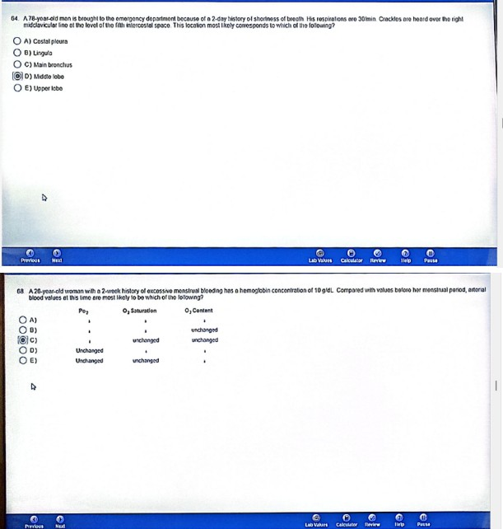

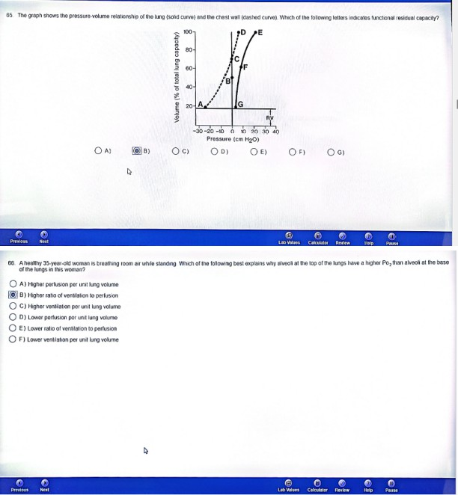

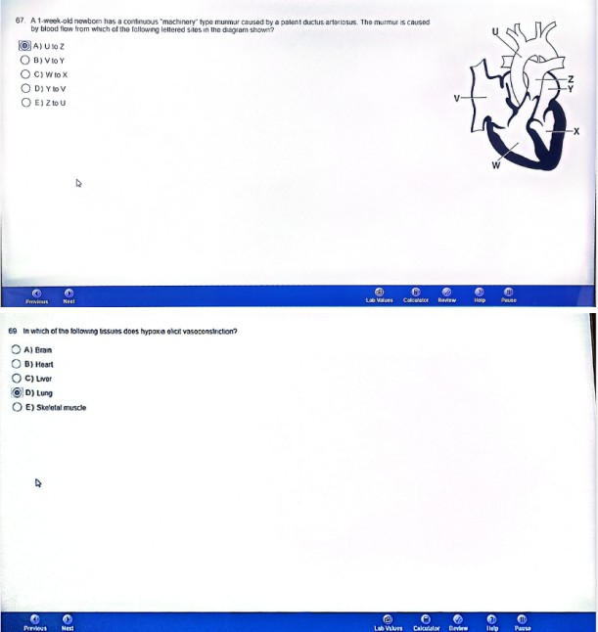

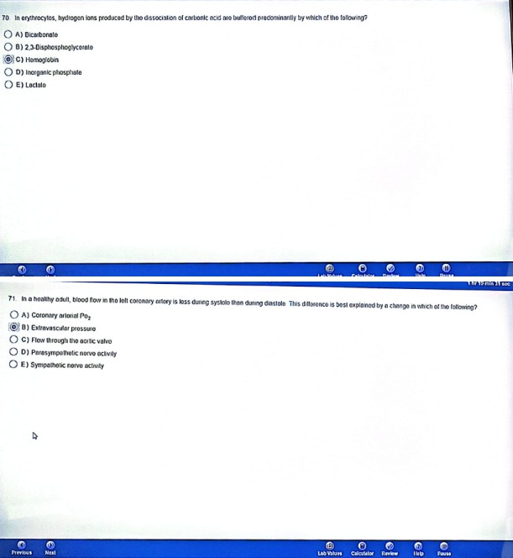

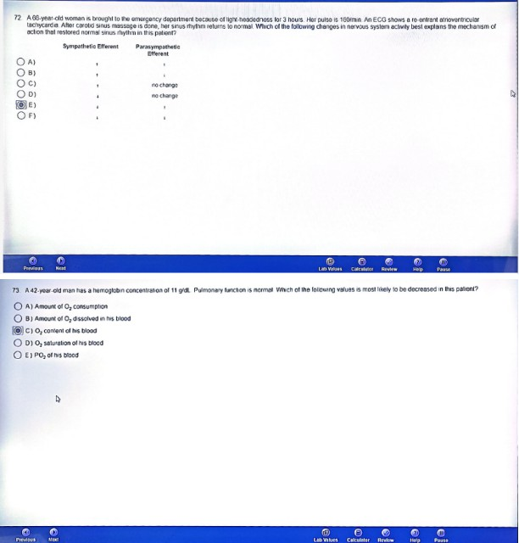

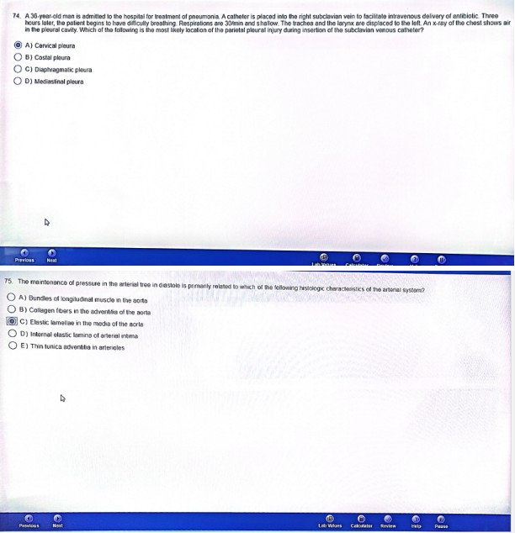

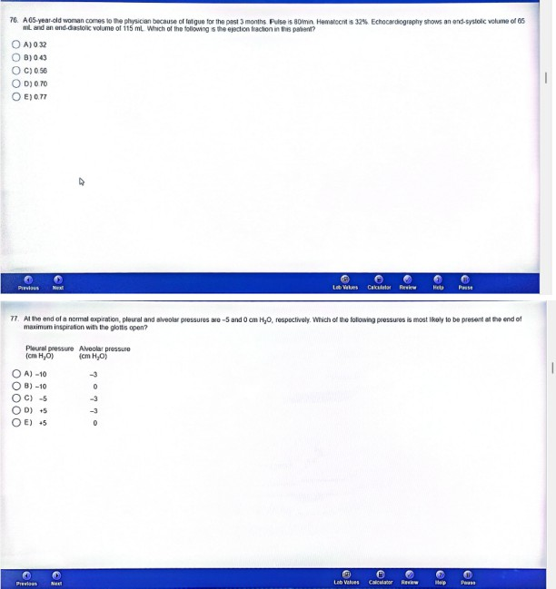







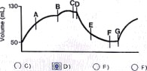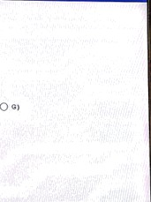O * 0 e›



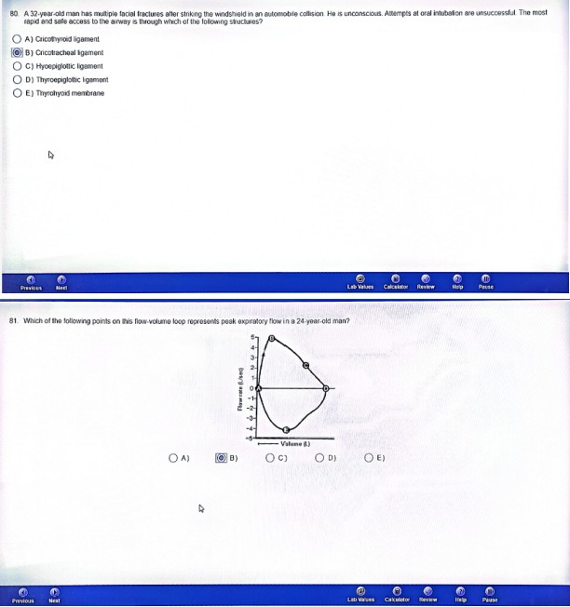

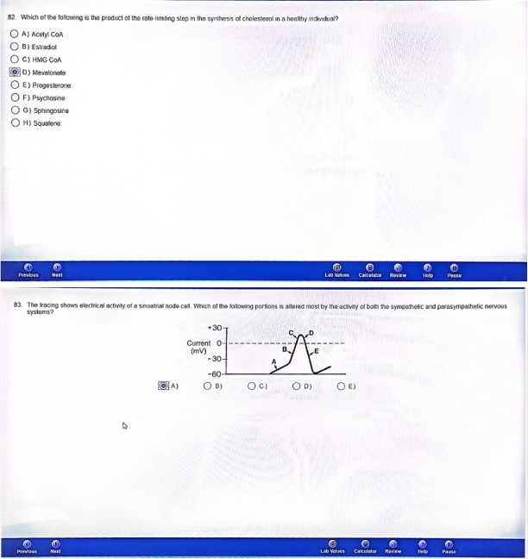

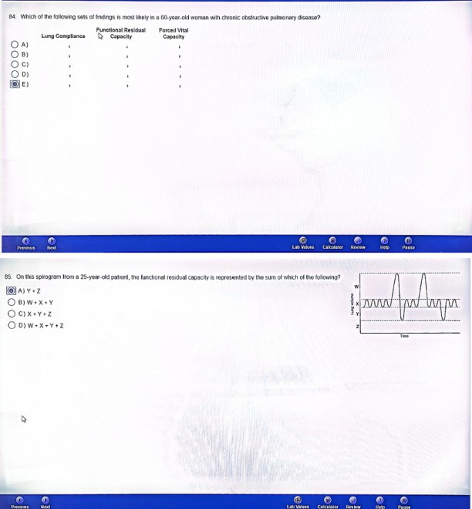

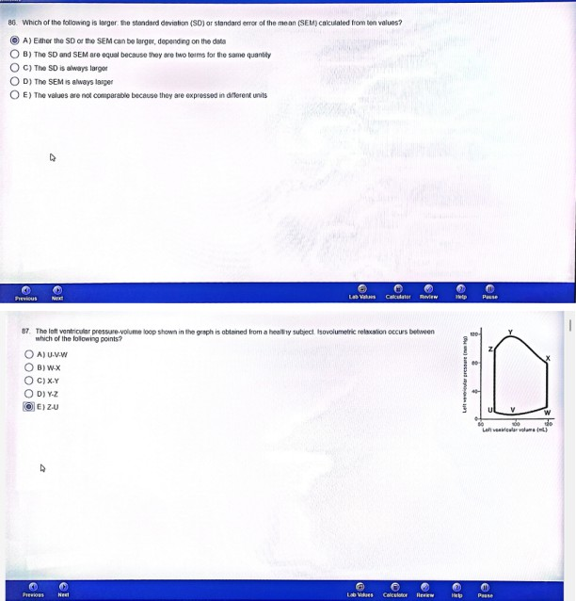

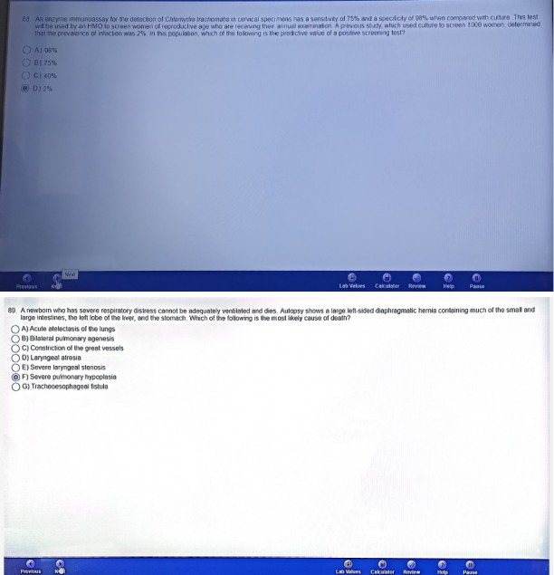

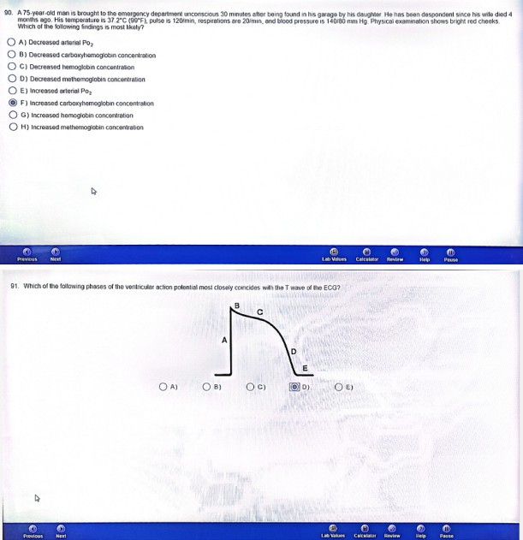









/lo› ,



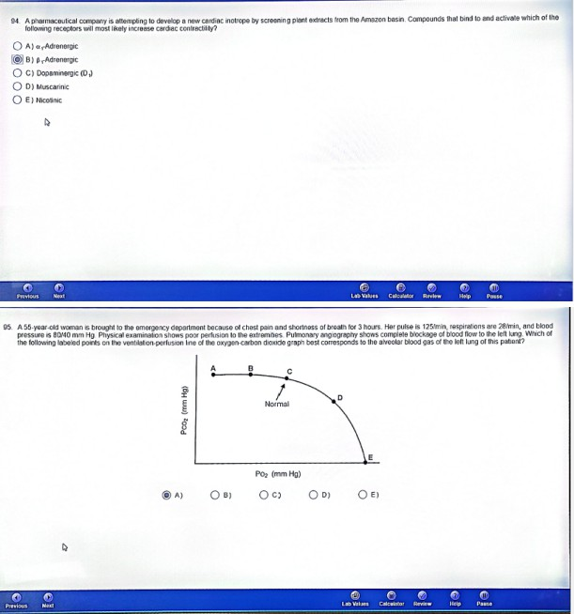

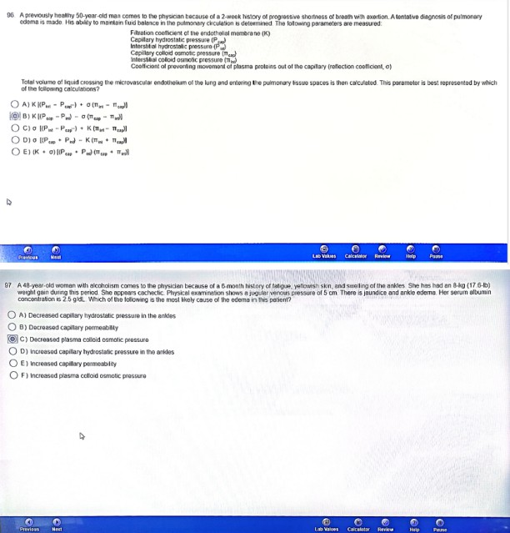

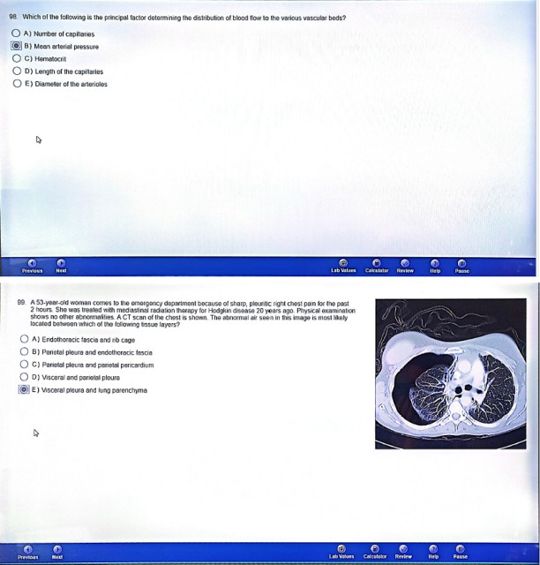



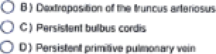





O •

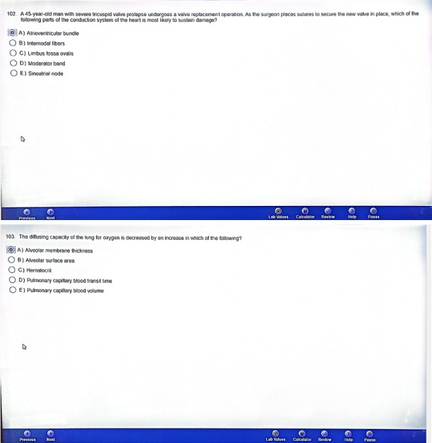

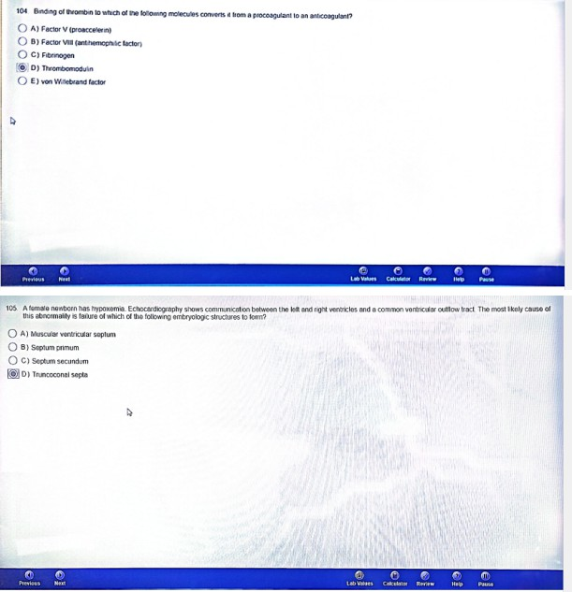

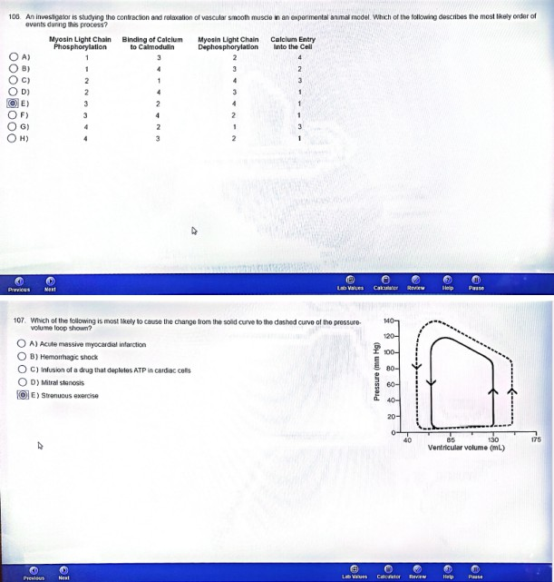

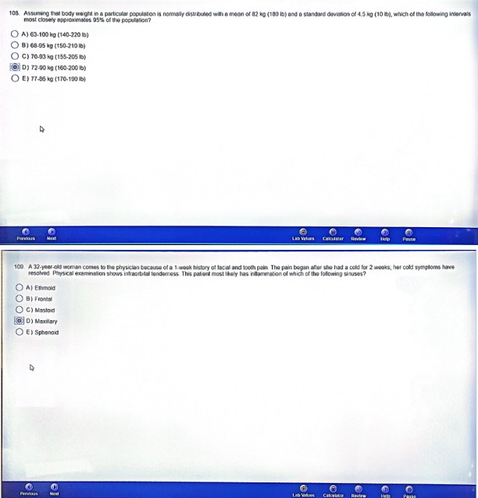

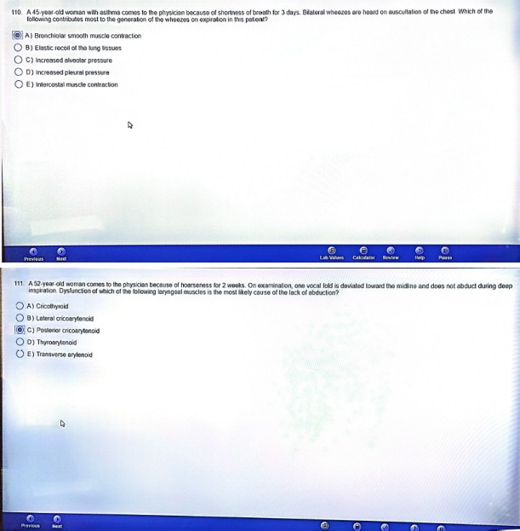

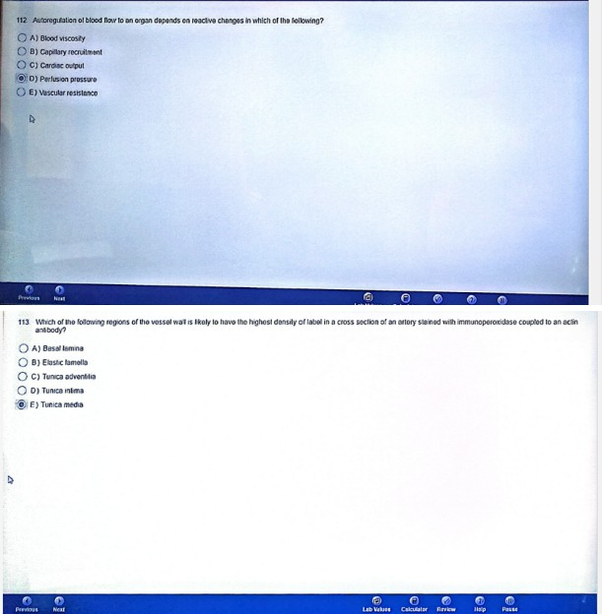

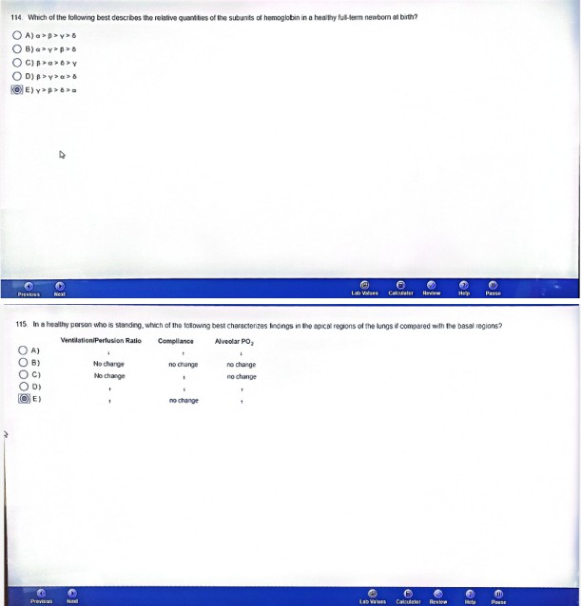

UG A bg year-old womanâ brought to tne ence gene y depa‹lmonl 1 Your anei lie s«doen onsnl ol ¢f«ShM tJ0sl9 Inal c h0S pain and nausea Physical oxan› nal on show pal›o• end daphoresis Art ECG 

 oxygen. ar›d a »ssue plasmiri en acl.vatoi Folln xing thrombolysis and ‹ef›erfus›on p0tenl al g Toxx suostanr.es inc} udtn9 I\ydrpgerj gu/cixzJ6 (! I U/

accumulate in Ihe cat•en ”s inJur0d hoart muscle V/hlr h nf Ice fclbwng enzymes r5 m 3St l60Iy to neu'reIiz0 lhis oxcoss H@t by rert‹ic•'ig I In wale I



### O C)MADPoxpu U}S er ms•w :aw

##### , El Xent•eoutxe



I JT \YhrrI i blo0d vassal is iyUiod or 5‹r.'orcd, the nfCceSs Ioad'ng (0 it0n›0stcS,S US ,¢›il,al0d TI\0 ñisl stop if› lrlis pi0C0SS ‹s yq5CUls‹ sg4sm PlatctojS COn1nb\›IO t0 VOsgSpOSnt izt

*! ,' h* ) ElaboloUon Of v4SCLI'4r 0‹IdOth0h0l pi0tv'th fCctor

0) Piosonco ol actin ana myos‹n in po\olct cylop\asn›

*fi,* C ) RodUCt›0n ol LhfO«›b0xaf›c ltd

 DQ Re'oaso o\ \hrombost»orvn

E ) Synooso at p os\eglor›d ns





nf a fover anal a pro‹1uctee cough X ray lems of fhe chest she n‹'ummir. «nnsoli‹tnI›on ni Ihe nulmnnnry V‘Jh<h of ihe k›O v ng Ir›bes is ‹he mosf /ikefx s•te of consoioaiion+

C j Right lower

|(‹B D › Right m done

*!0 IN fdXnW\g v8riab\es were measured in a 30-yeer-‹ •d roman during execc•se

Oxygan consumpuor› SfXl mL/m n

Hem‹•oio»in concenys‹on ›p g tqp mL

h1ean a‹tor ai to vonpus oxygen concenyalon ol‹e‹ence 5 mL Oyt00 mL blood

Wl›'Cl› of fh6 follo›' r›9 iS ltte ntean C8rd 8C outeul ( n L ¥›t n) negded la sUS e•n Oxpe« delivery to Issue?

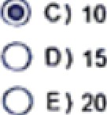



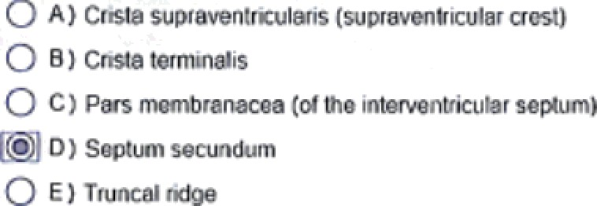



1. Platelet-platelet Ending, or aggieyalion, requires tha in oract‹on of fibiinogen with a eceptoi on activated p\cteIe\s Which o\ lh8 following is the most I keiy composition of this

ieceptoi?

* 1. Factor XII (Hageman facto›

B ) Glycopiotein lb/IX G C) Glycoprotein IIb/lIIa O D ) Plasmon

E ) Thiombin







2 In which of lhe lo\1ow ng portions of (lie ciiculatio is bloo0 volume the gfea ast?

O • ) Cardiac chambers and vessels

* 1. Pu\inonaty arteNes, veins, and capllaries
  2. Syst6TNlC QfȚØ'f 9S

D ) SyStefIJIC Cä illăfl0S

E ) Systenac veins



3 Wh›ch ol \t\a tOl*Ow ›9 Ove tS occurs due n9 t '›o nxp rnlory f łUi?n Ol menu.x»0n*

< 9 A) Conlioct•on Ø tho oxtoțrrst int‹ iccisțat musd‹•s

1. Eł‹r•aton ot ihe +s

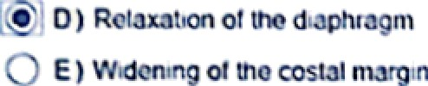



4 10 SCfe6rling iOf 9 aLlCome. an intraoc ulor pressure of 20 min Hg nsteed of 25 mm Hg is used as the cut Point foi normal Wi›ich oJ tlio loIIow›ng is who most l›kety effect on tha

peed ctive va!ues1

O Ay

O B)

O c

##### D l

Om



Pesitive Fjegadye

Predlctive Value Predlctlve Value Dccroaso dccreaso

##### Decrease increase

Decrease no change

lncrease decrease

i0Cf00Se inc ease

lncrease no change

No change decrease

No change increase

No change no cl ape





S Xhthol| elobw+ gas h0n;os(Ike efoc|o|a SOY0eceasemimpWsOcoodvclooveoc|yñiougtthoafoU0&lfm|afnodo7

) A 50% decrease in heart late

O B) increased PP int9rva\ on an ECG

#### \ncreaseJ Pn interval on an CCG

* 1. Increased splitting ol St on insPiia\›on

E ) P oIonged dU ation of ihe ORS niervai on an ECM



5 t"’-• *\°* 8•* *ti0.• r5 r‹'*at8 Jx-,6e•- • eat,' *•o- -w \æa,-k•"' •8.:WV’tt.+" '-ș « r'w:» v», + c:.s›''.,v

*.-* Ę: i.‹., TdT.rd I.,dt°,:',:t.,tt M g.g gt,dt,>,-t tç- ,T„t--.d,-

ȚtF't!r°-4r°°.d r.°.4.°4hh Jt,.- ,.T °.°T.°'!•t t• t.ti:ti.- t

ÇȘ’ D’ 'r -'aa-r"ir->•Ł , i , ,4-^, •’,

,ÿ r u r i a

L



Y



r \r.\\æ u,ë<., ,'-•.-.-- '.„ -a , -; o.' • -.-::.-.- •o -.i !-' ńu\\ • r.-r- a' , -ar o.u\"•ü# i #-,'w-••' s-•' • :•-•*••’""r', •, r’ 8" "!8t•,"•’. '** ''. ,' "-"' '-"’•"+ 8*8 -"8* '* ""' "' "'8



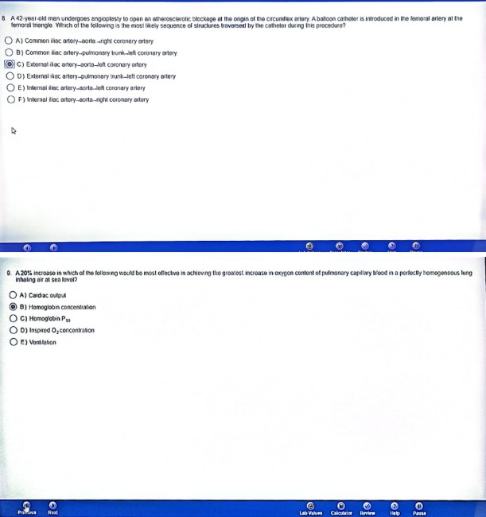

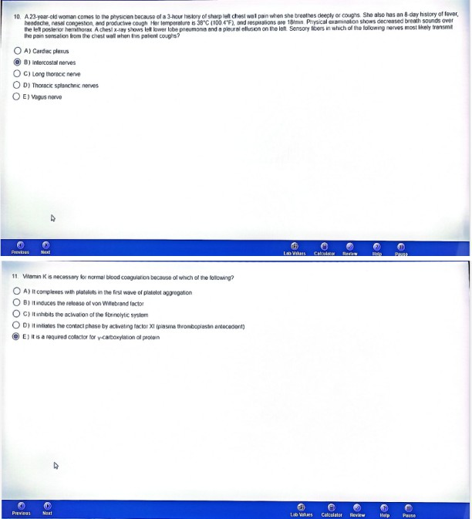

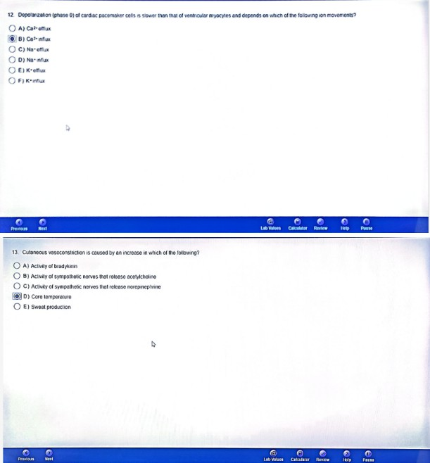

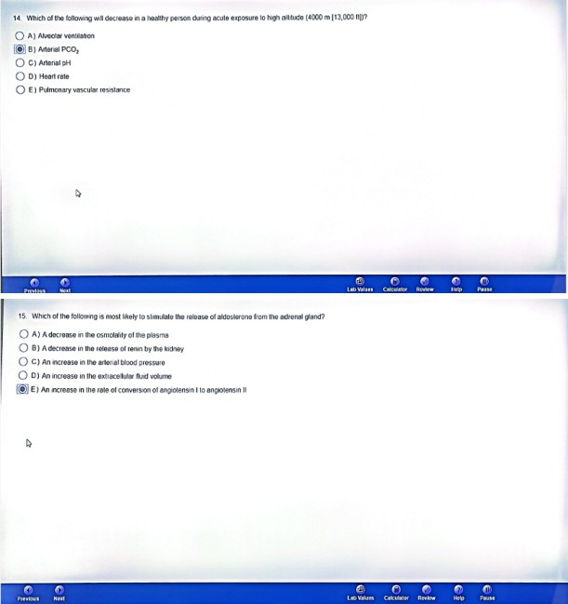

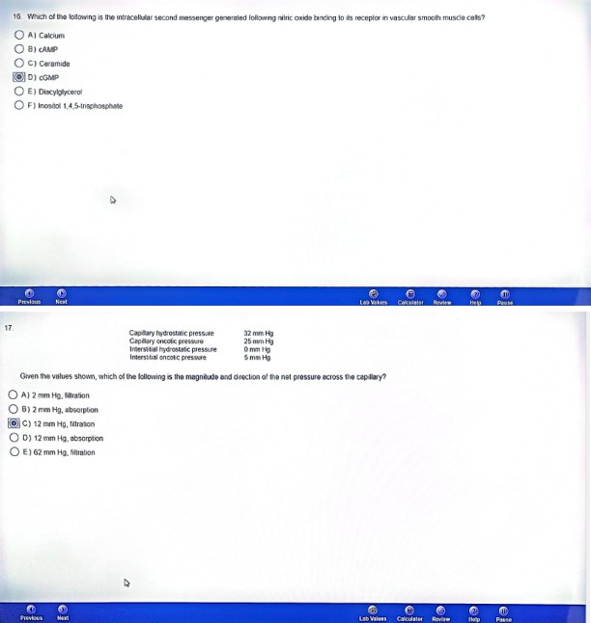

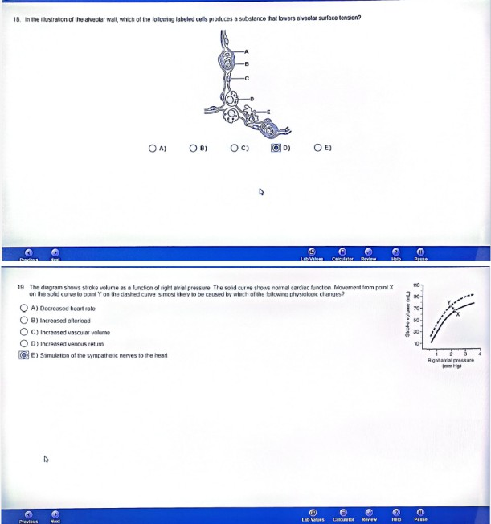

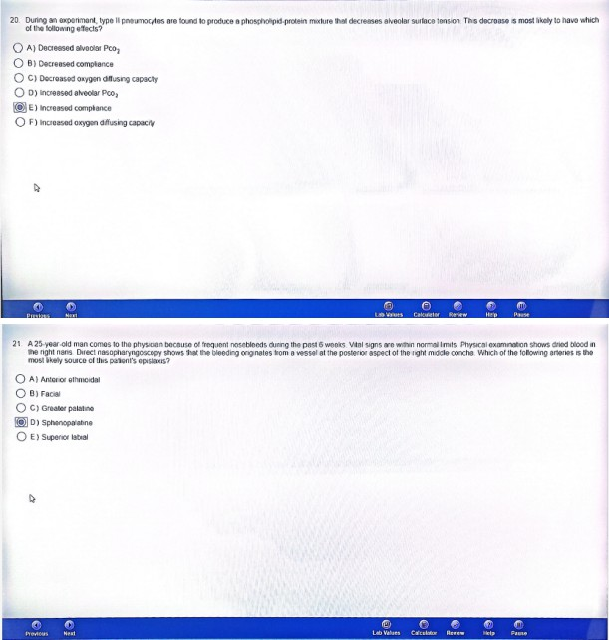

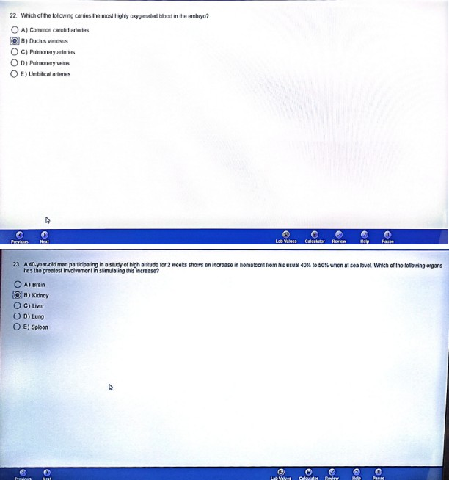

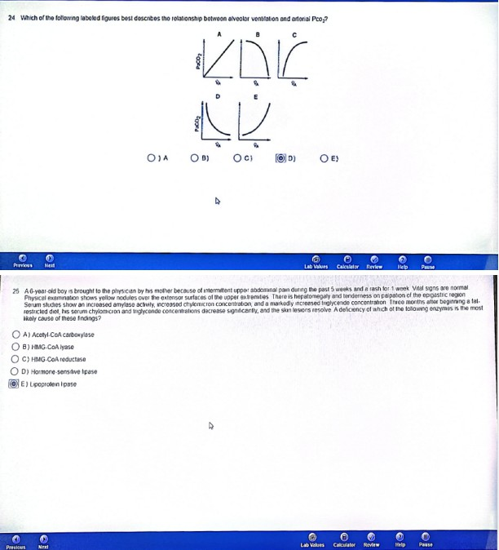



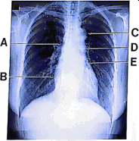

O*› O*+ O i Æ › O•



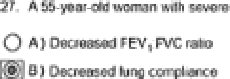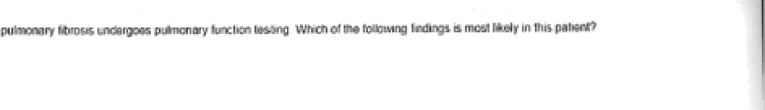

O •›—--





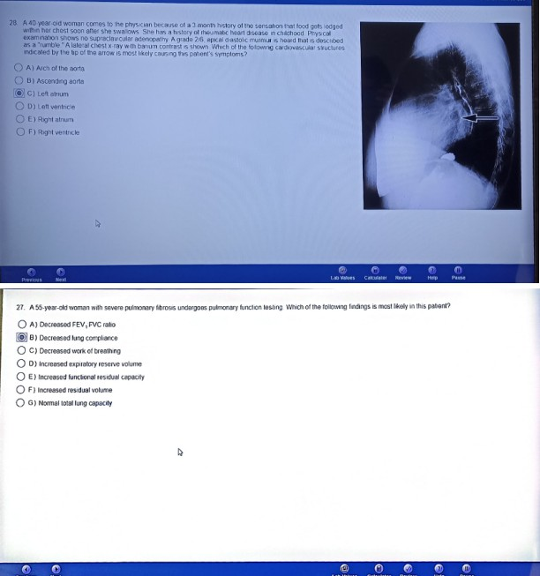

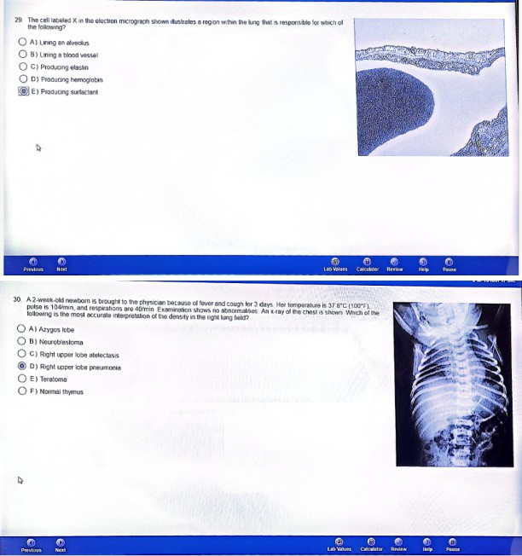

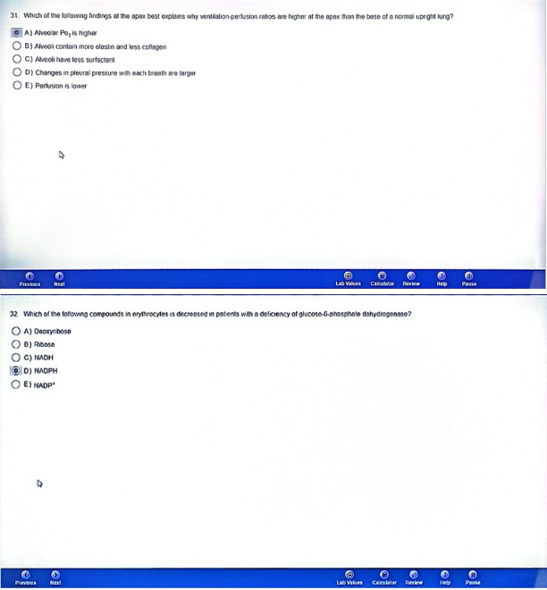

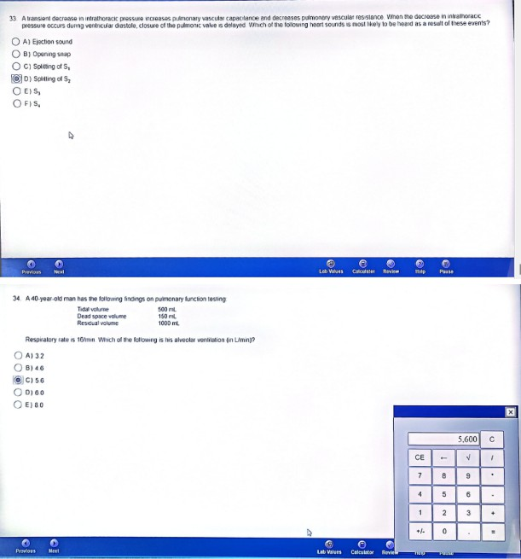

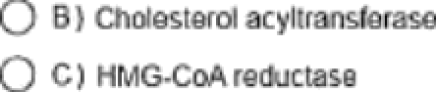

cñoesteicJ concan\ ntion 's 840 n›g/dt., seium HOL cho*esieol

F ) I ysosomnl rhoIco›eioI e•torasa